Product Specifications

POE1621Q
（48V Standard POE：IEEE802.3af/at）

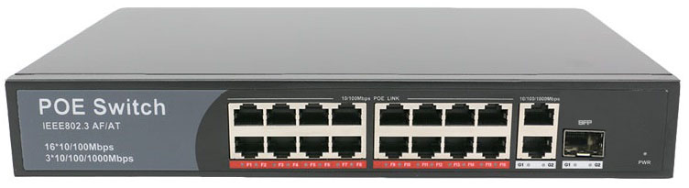
Feature
◆Can supply power to wireless AP and IP Camera
◆16*10/100Mbps auto-sensing RJ45 ports, 2*10/100/1000Mbps,1*1000Mbps SFP.
◆Total PoE power: 200W (Port 1 to Port 24)
◆Maximum power per port ups to 30W
◆Support Auto MDI/ MDIX
◆Support anti-thunder to port(AC power port: Differential mode + / -2kv, common mode + / -4kv)
◆IEEE802.3 10Base-T, IEEE802.3u 100Base-TX, IEEE802.3z, IEEE802.3ab
◆Flow control mode: full duplex adopts IEEE 802.3x standard, and half duplex adopts Back pressure standard
◆Adopt store-and-forward architecture. Up to line speed at the frame length range of 64 to 1536
◆Built-in 1U rack power supply series, easy to place it into standard mounting brackets
◆Plug and play
This POE1621Q switch provides a network point for power supply and data transmission. All the 16 PoE ports can be connected with 10/100Mps quickly, and the uplink port is 1.25Gbps fiber interface, among which 1-16 ports can provide standard IEEE802.3af/at power supply. Due the advanced self-sensing algorithm supply power for IEEE802.3af/at terminal unit only, there is no need to worry about damaging proprietary PoE or non-PoE standard equipment. In addition, it will stop power supply when PoE devices are not connected. In short, The POE1621Q features simple and reliable design, automatic identification PoE requirements, duplex and high-speed.
This cost-effective POE1621Q provide network layout need to simplify wireless access point (AP) and IP-based surveillance cameras network cameras in order to install in commercial network and home network. The devices far away from power socket are very suitable for hanging on the wall or ceiling. PoE eliminates the need for connecting these devices to power socket. So it make more flexible for those difficult to connect with AC power socket, and cut down the installation cost. It is ideal choice for those want to deploy a small commercial network and home network that use wireless access point (AP) and IP-based surveillance cameras.
Target Industries
◆HD monitor transmission and power supply
◆Wireless AP layout transmission and power supply
◆Network telephone transmission , intelligent house and home system
◆Intelligent transportation supervisory system(ITS)
◆ High-speed Way supervisory/Tele-Communication System
◆ Security protection system, TV medical treatment
◆ Long-distance Muti-media Schooling, Campus monitoring
◆ Long-distance broadcast television transmission system
◆ High-building Security Protection, Military Tele-Com projects
Ordering Information
Product Model: POE1621Q
Product Description: 16x 10/100M Ethernet PoE ports + 2x gigabit ports+1x SFP, PoE switch, and 1-16 ports supports IEEE802.3af/at, total power is 200W.
Ordering Notes: PoE default power supply is end-span(1/2, 3/6 line pair), alternative PoE
Power supply is mid-span(4/5, 7/8 line pair)
Technical parameter list
Product Name | 16-Port PoE Switch with 2 Gigabit TP/SFP Combo ports
Model | POE1621Q
Connector Type | 16*10/100Mbps auto-sensing RJ45 ports, 2*10/100/1000Mbps,1*1000Mbps SFP
Network Media | 10BASE-T: Cat3,4,5 UTP(≤100 meter) 100BASE-TX: Cat5 and more UTP(≤100 meter)
Bandwidth | 15.6Gbps (non-blocking)
Address Database Size | 16K
MTBF | 100,000 hours
Network Latency | maximum delay less than 20 microseconds
Forwarding Mode | Store-And-Forward
Buffer Memory | 4M
Network Protocols | IEEE 802.3i 10BASET IEEE 802.3u 100BASETX IEEE 802.3x Flow Control IEEE 802.3af DTE Power via  MDI IEEE 802.3af/a
LED Display | System: power supply Every Port: connecting, PoE working status
Power Supply | AC100-240V 50/60Hz; (every country use a custom power plug)
PoE Ports | 16*PoE Ports
PoE Port Power | Max 30W
PoE Standard | IEEE 802.3af/at
Working Environment | Operating Temperature: -20 ° ~ 55 ° C Storage Temperature: -20 ° ~ 75 ° C Humidity: 10% ~ 90%, non-condensing Storage Humidity: 10% ~ 95%, non-condensing Working Altitude: 3000 m (10,000 ft)  Storage Altitude: 3,000 m (10,000 ft)
Certification | CE Mark ,commercial CE/LVD EN60950
Radiation | CE mark, commercial FCC Part 15 Class B VCCI Class B EN 55022 (CISPR 22), Class B
Product Size | 270mm*180mm*44mm,2kg
Warranty | 3 year

