|  |
| --- |
| **HD / IP Video Extender over Coax Cable** |

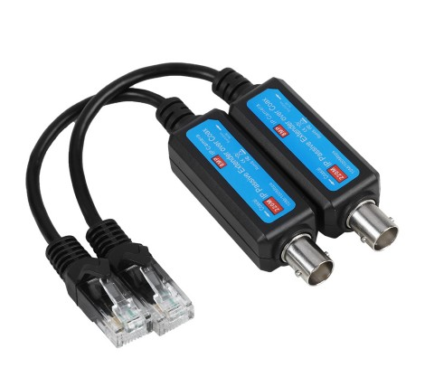**ST-IPVE8**

**Packag**e:

**IP EXTENDER** is Designed to Extend IP Camera signal over existing coaxial cable, Transmission distance reaches max up to 220 Meters at 10Mbps Speed, IP EXTENDER is low cost and easy, simple and Speedy migration from analog to IP Camera’s using existing coax cable, Support IP Camera up to **8MP** Resolution.

It widely use at Security Monitoring System, Multimedia Network Teaching System, Industrial Automation Control System, Banking, financial information display system, Hospitals, department store security, School campuses and so on....

**Product Feature:**

* 1 Channel Passive IP Extender over Coax
* Transmit IP Camera signal over existing coaxial Cable
* Transmission Distance max up to 220 Meters
* Passive Device, No Power Required
* Transmission Rate/Bandwidth:10/100Mbps . Half/Full Duplex Transmissions
* Built-in Surge Performance
* Fast and easy to install

**Specification:**

|  |  |
| --- | --- |
| Product Name | Passive IP Extender Over Coax Transmitter / Receiver |
| Applied devices | CCTV Cameras, Monitors, DVR, Switchers, IP Encoders, and related CCTV equipment, |
| Video Format | PAL, NTSC, SECAM |
| Standard | IEEE802.3 10Base-T |
| Bandwidth | 10/100Mbps |
| Impedance | 5Ω to Dual 100Ω or 75Ω to Dual 100Ω or 93Ω to Dual 100Ω |
| Max Distance | 220M / 720Ft |
| Crosstalk | >30dB |
| Connector | Female / Male BNC, RJ45 Jack |
| Cable | Coax Cable (RG59) |
| Power | NO External Power Required |
| Housing | ASB Engineering Plastic |
| Body Color | Black |
| Dimension | 40X19.5X18.5 (LXW*H) |
| Net Weight | 40g |
| Operating Temperature | -20°~70℃ |
| Relative Humidity | 0~95% (Non Condensing) |
| Storage Temperature | -10°~150℃ |

**Diagram connecting:**

