Local monitoring management system instruction manual

Version 3.0

Statement

Thank you very much for purchasing our products. If you have any questions or needs during the use, please feel free to contact us.
This manual is written according to the current software and hardware. Due to the update, modification and upgrade of the software version, and the upgrade of the hardware device, the technical problems described in the manual may be inaccurate or imperfect. Please understand.If you cannot solve the problem according to the manual during use, please call our technical department for relevant operation methods.The manual will be updated regularly. If necessary, please go to our official website for download without prior notice.

Tips

Recommended PC basic configuration: CPU quad core 3.0GHz, 4G memory, 512M discrete graphics, 2.1 sound card, Audio output, MIC input, WindowsXP/7/8/10

Contents
1.Client overview 1
2. Client installation and uninstallation 1
2.1 Installation 1
2.2 Uninstall 2
3. Client login 3
4.Client common function configuration 4
4.1 Features 4
4.2 Configuration 4
5.Equipment management 4
5.1 Auto Search 6
5.2 Add device 6
5.3 Modify device 7
5.4 Remote configuration 7
5.5 Delete device 8
5.6 Directory upgrade, file upgrade, and upload configuration 8
5.7 Video plan 9
5.8 Restore factory, reboot device and download configuration 9
6. Preview 9
6.1 Tree list view 10
6.1.1 Device List 10
6.1.2 Grouping 11
6.1.3 Device Configuration 11
6.1.4 Search and view devices 11
6.2 Image list view 12
6.2.1 Device Configuration 12
6.2.2 Search and view devices 12
6.3 PTZ control 13
6.4 Real time monitoring 14
6.4.1 Real-time monitoring operation 14
6.4.2 Dual stream monitoring 14
6.4.6 Audio 15
6.4.8 Stop preview 15
7. Local playback 17
8. Remote playback 17
9. System settings 18
10. Other 19

1.Client overview
The local monitoring and management system uses the local area network as the medium channel to centrally monitor, capture, record, receive/process alarms, view historical recordings, and remote intercom, and broadcast to multiple monitoring points. .
This user manual is provided for users who use the local monitoring and management system. You should have basic operational knowledge and experience in related equipment (such as IPC, NVS, DVR, etc.). If you have not used any related equipment such as IPC, you can use this manual in conjunction with the IPCAMERA Instruction Manual V3.0. This will enable you to quickly use our products.
The system is being further designed and improved. Please pay attention to the official website of our company and download the latest version of the system installation and use. Please understand that the functions of the system are not perfect. We kindly ask you to give us valuable comments to encourage us to improve the system better. We are very grateful for your suggestions.

Client installation and uninstallation

2.1 Installation
- Double-click the LMS_install_Vx.x.x_xxxx.exe installer and select the installation language.；
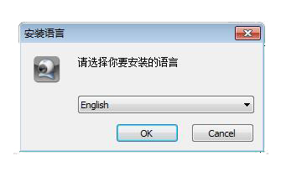
- Click the "OK" button to launch the installation wizard;
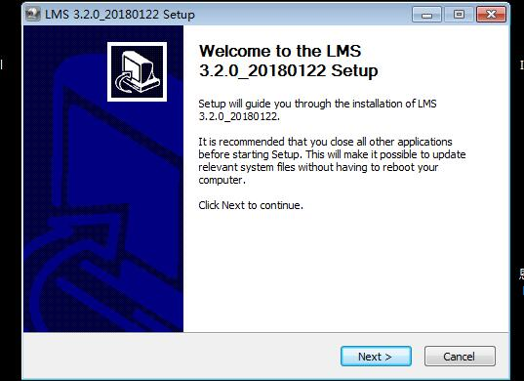
- Click the "Next" button to enter the Select Installation Location screen and set the program installation directory;
- Click the "Install" button to start the installation;
- The installation completion screen is displayed. Click Finish to exit.
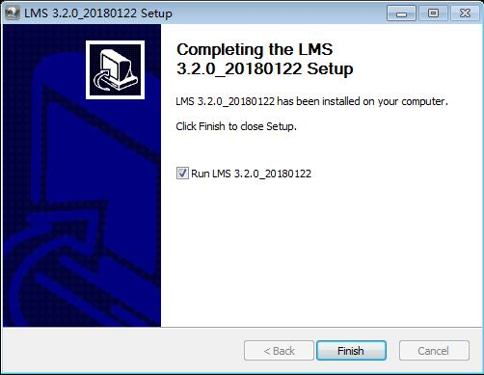

2.2 Uninstall
Click the [Start] button to select Settings → Control Panel → Programs → Uninstall Programs, select “LMS x.x.x_xxxx” in the uninstall or change program interface, right click on the mouse to uninstall or double-click the item to uninstall (as shown below).
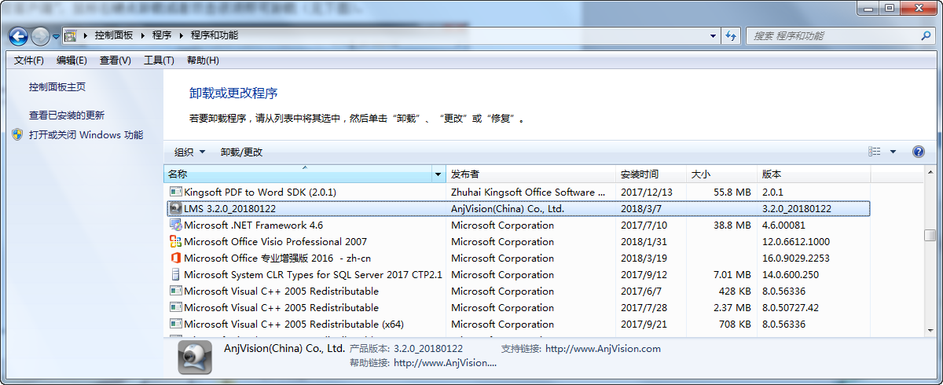

Client login
After the client is successfully installed, run the client and enter the login interface as shown below. Enter the user name and password to log in.
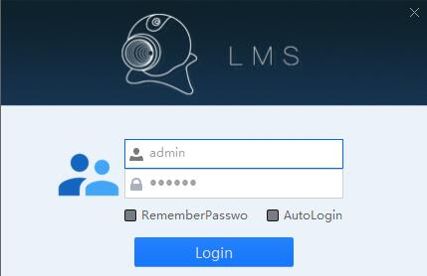
Username：User name for local login, the initial value is: admin;
Password：The password for local login, the initial value is: 123456, which can be changed after login.
Remember password：After checking this item, you do not need to re-enter your password to log in again next time.
Auto login：After checking this item, the next time you double-click the client icon, you do not need to enter a username and password to enter the system directly.

4.Client common function configuration
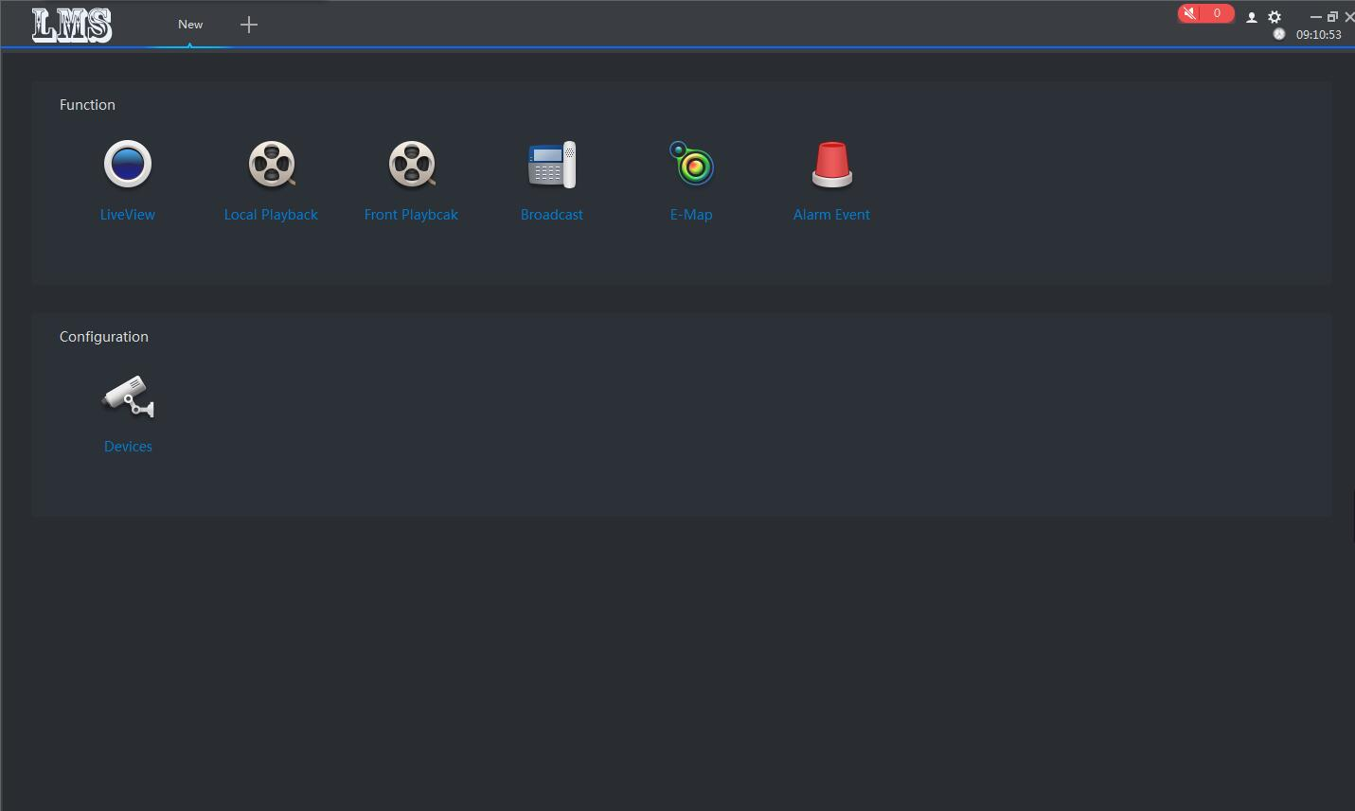

4.1 Features
Preview：Perform real-time preview operations on the packet channel, as well as perform operations such as recording, capturing, and pan/tilt.
Local playback：Search and play back local video files of the packet channel
Remote playback：Search and play back remote recording files of group channels
Broadcast：Support for calls and MP3 broadcasts
Digital map：User-friendly layout and positioning device
Alarm event：Record and query alarm information

4.2 Configuration
Equipment management：Add, delete, modify, upgrade devices

5.Equipment management
In the configuration bar of the new function interface, select “Device Management” to enter the device management page (as shown below).
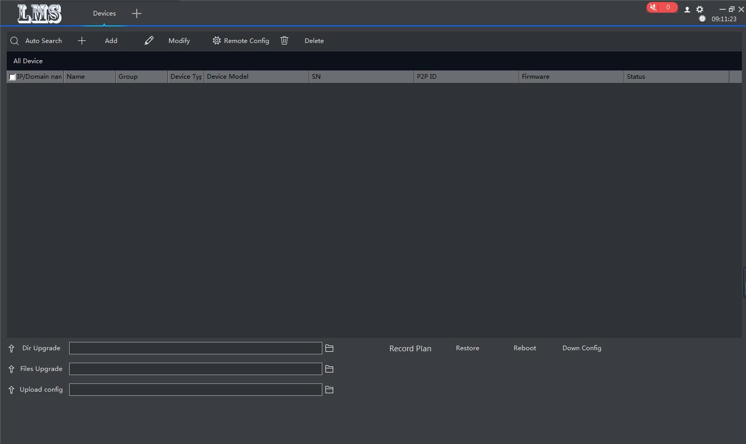
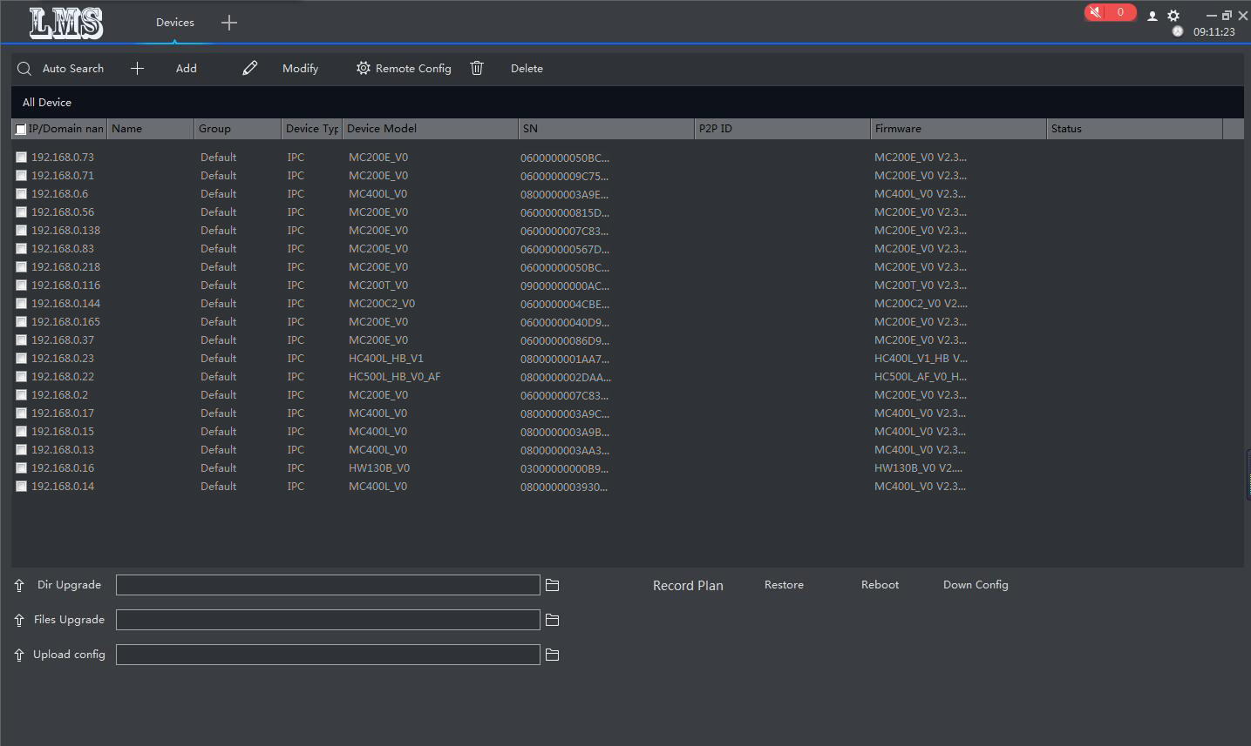

5.1 Auto Search
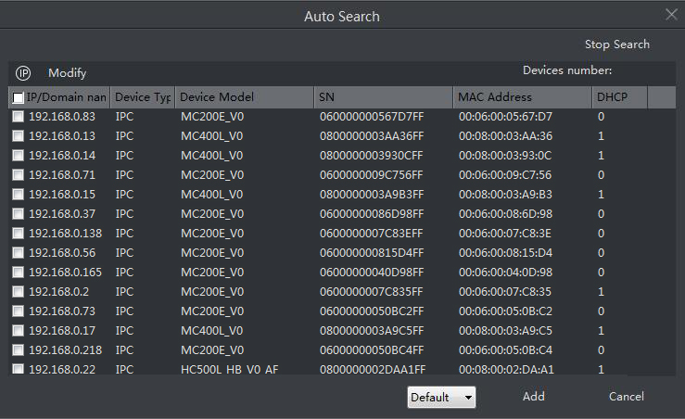
Can search all devices on the same network segment, modify IP and group

5.2 Add device
You can manually add devices, including name IP, video port, PTZ control port, group, account, password (default admin, 123456) for editing. * Is required
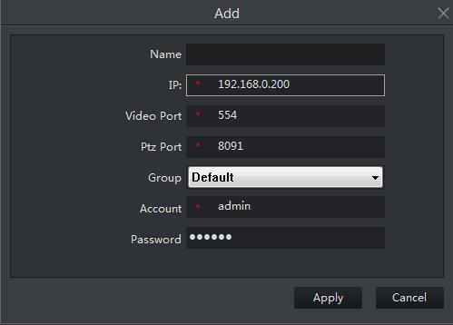

5.3 Modify device
This feature can modify the display information of the device. Including name IP, video port, PTZ control port, group, account, password can be edited. 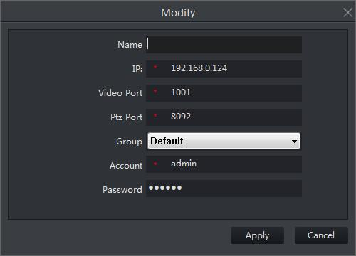

5.4 Remote configuration
The settings that can be made include: network settings, media settings, pan/tilt settings, storage settings, alarm settings, system settings, etc. The relevant usage methods are described in detail on the front-end devices.
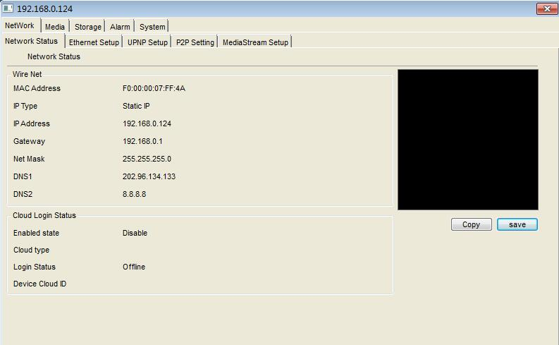

5.5 Delete device
Deleting a device that has been added by the client is not recoverable. Please be cautious.

5.6 Directory upgrade, file upgrade, and upload configuration
Directory upgrade：Click，Select the appropriate folder and click "Directory Upgrade" to upgrade
File upgrade：Click，Select the appropriate file and click "File Upgrade" to upgrade.
Upload configuration：Click，Select the corresponding configuration file and click "Upload Configuration" to upload the configuration information. The corresponding configuration information takes effect immediately, but the factory reset will be reset.
Note：
- There will be a status prompt if the upgrade is successful or not.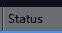，If the upgrade is unsuccessful, you can repeat the upgrade once. If the upgrade is not successful, you need to power off the front-end device before upgrading. The upgrade status is displayed during the upgrade.
- Do not power off the front-end equipment during the upgrade to avoid program loss.

5.7 Video plan
The corresponding recording plan can be customized in batch or separately, including timed recording, motion detection recording, alarm recording, and clearing the recording.
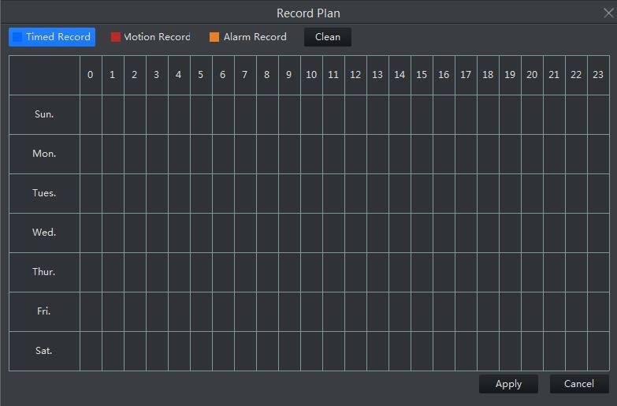

5.8 Restore factory, reboot device and download configuration
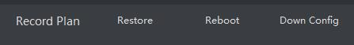
After selecting the device, click “Restore Factory” to complete the factory default reset operation.
After selecting the device, click “Restart Device” to complete the device restart.
After selecting the device, click "Download Configuration" to download the configuration information of the corresponding device.

6. Preview
After the configuration management has added the device, in the configuration bar of the new function interface, select “Preview”, then jump to the video browsing interface, you can browse the video in real time (as shown below) 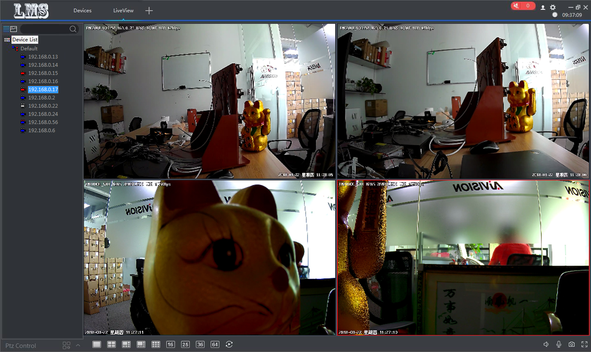

6.1 Tree list view
Click，Switch to the tree list view. Devices can be grouped, deleted, and added.
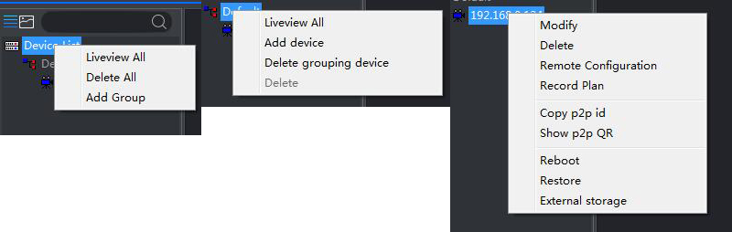

6.1.1 Device List
Right click,You can preview all devices, delete all devices under the list, and add groups (pictured above)

6.1.2 Grouping
Right click，You can preview all devices under the current group, delete all devices in the group, and delete the group, but you cannot delete the default group (above)

6.1.3 Device Configuration
Right click on the corresponding device,You can modify the device, delete the device, set the remote configuration view, set the recording schedule, copy the P2P ID, generate the QR code, restart and restore the factory settings, and view the external storage (above).

6.1.4 Search and view devices
Search device：Enter the corresponding device name, you can find the corresponding device, the background color of the searched device turns white (as shown below)
View device：The mouse will display the IP serial number and device type after staying on the IP for about 1s.
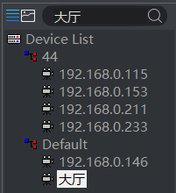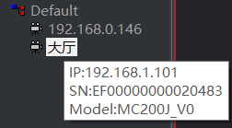
Device status：
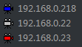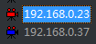
Blue：Equipment online
White：Device offline
Red：Device is previewing
White antenna：The device is not recorded
Red antenna：The device is recording

6.2 Image list view
Click，Switch to the image list view. Adding and deleting devices can be done.

6.2.1 Device Configuration
Right-click the corresponding device to modify the device, delete the device, set the remote configuration view, set the recording schedule, copy the P2P ID, generate the QR code, restart and restore the factory settings, and view the external storage (as shown below). 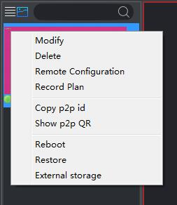

6.2.2 Search and view devices
Search device：Enter the corresponding device name, you can find the corresponding device, the background color of the searched device turns blue. (As shown below)
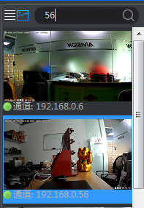
Device status：The preview will be taken after the preview
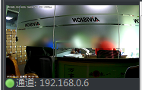Green dot: device online
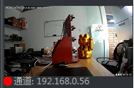Red dot: device video
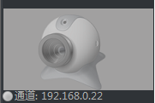White dots: device offline

6.3 PTZ control
Through the PTZ control interface of the client, the corresponding PTZ control can be performed. The control window can be fixed or active (as shown above), including up, down, left, right, focus, aperture adjustment, step adjustment, zoom, pre- Set the operation. When the user performs the up, down, left, right, aperture, focus, and zoom control, press and hold the left button on the corresponding function button to start, and release the left button to stop.
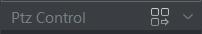
PTZ folding
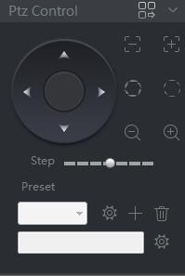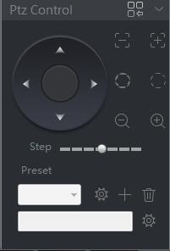
PTZ control interface unfolds (left) and expands (right)
Note：
Firmware without AF click this item does not work.

6.4 Real time monitoring
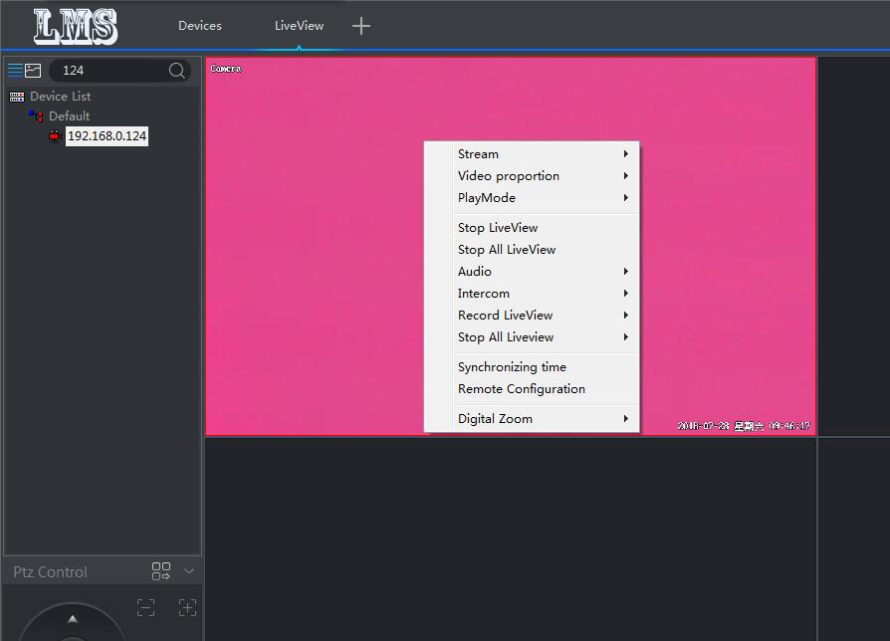

6.4.1 Real-time monitoring operation
- In the preview interface, select a device to double-click in the device tree list, and display the real-time video stream of the device in the first window of the monitoring area that has no video stream;
- In the preview interface, select a device in the device tree list and drag it to a window in the corresponding video window area, the window will display the real-time video stream of the device;
- In the preview interface, select the device group name in the device list, right-click the mouse, the drop-down window appears, and click “Automatically play the group device”, the system automatically starts playing the online device video stream from the first window.

6.4.2 Dual stream monitoring
Due to the limitation of network bandwidth and the high definition of video images, front-end equipment such as IPC adopts dual stream technology. That is, the code is generated at the same time to generate two completely different code streams (including different resolutions, frame rates, picture quality). The main stream is used for local real-time storage, and the sub-stream is used for remote network transmission, which takes into account the high quality requirements of local storage images and the fluency of images transmitted over low bandwidth in remote networks. Reach the network bottleneck and maintain the full effect of local HD storage.
Select the screen, right-click shortcut menu, select the corresponding code stream to switch the code stream.
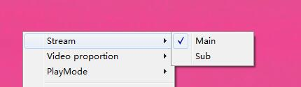
6.4.3 Video proportion
Select the screen, right-click shortcut menu, select the video scale, and realize the full screen and original scale display switching of the current window.

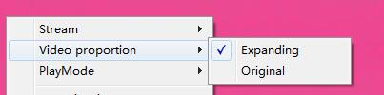
6.4.4 Play mode
Select the screen, right-click shortcut menu, and select the play mode to switch between the real-time and smooth screen display of the current window.
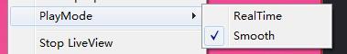
6.4.5 Voice intercom
Select the screen, right-click shortcut menu, select intercom, you can open the intercom, real-time two-way voice intercom function for the front-end equipment.
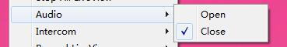

6.4.6 Audio
Select the screen, right-click the shortcut menu, select Audio, turn on the audio, and hear the sound received by the pickup.
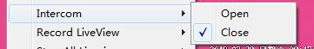
6.4.7 Preview video
Single preview video: Select one screen to manually record the video of this screen.
Preview all videos: When the device is previewing in real time in the preview screen, click on any position of the preview screen to record all the pictures of the device being played. Click Close to close all preview videos.

6.4.8 Stop preview
Right-click the corresponding device and click "Stop Preview" in the right-click menu bar to close the current preview screen; click "Stop All Preview" to close all preview images.
6.4.9 Electronic amplification
Select the right button of the device and click “Electronic Zoom” in the right-click menu bar to select the zoom in, zoom out, drag and drop functions to achieve the desired zoom effect.
Zoom function: the mouse will change into a magnifying glass pattern, click the left mouse button, the position of the mouse will be enlarged, the image of the forward rolling pulley will be enlarged, and the image of the rolling roller will be reduced;
Zoom out function: the mouse will change to the reduced mirror pattern, click the left mouse button, the mouse position will be reduced, the forward scroll wheel image will be enlarged, and the backward scroll wheel image will be reduced;
Drag and drop function: the mouse will change into a drag pattern, dragging the mouse pattern will move, the forward scroll wheel image will be enlarged, and the backward scroll wheel image will be reduced;
Disable function: The mouse resumes the pointer pattern, and other zoom functions are turned off.
6.4.10 Screen format switching
Click the corresponding split screen button in the toolbar below the preview live stream to switch to the monitor of different screen formats. The following screen selections are available: 1 screen, 4 screens, 6 screens, 8 screens, 9 screens, 16 screens, 25 screens, 36 Screen, 49 screens, 64 screens.
6.4.11 Round tour
You can perform single and quad rounds by clicking the corresponding round button in the toolbar below the preview live stream.

Local playback
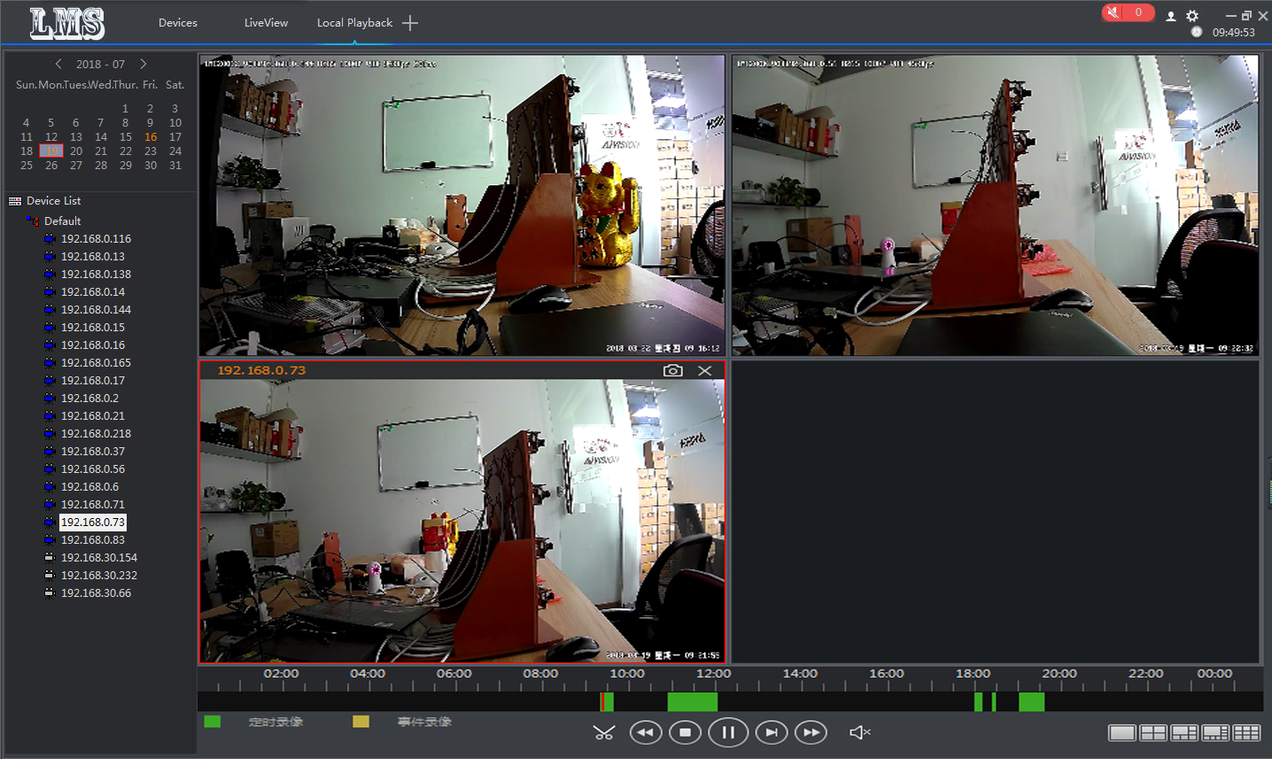
Local playback is playback of the recordings in the recording schedule configured in [Configuration Management] -> [Recording Schedule], and the local recording files are saved in the local computer. In the playback window, the user can operate the toolbar below the player to implement time clip (reservation), rewind, stop, pause/play, frame advance, fast forward, sound and other functions. It can perform 1 picture, 4 picture, 6 picture, 8 picture, 9 picture simultaneous playback and different time period playback. Capture images are stored by default in the \LMS\SnapShot file, or you can view them in [System Settings] -> [Snapshot Directory].
- The device list selects the corresponding IP. The background color of the date on the calendar will turn orange, and the video progress bar will also appear green (timed recording) or yellow (event recording) as shown below;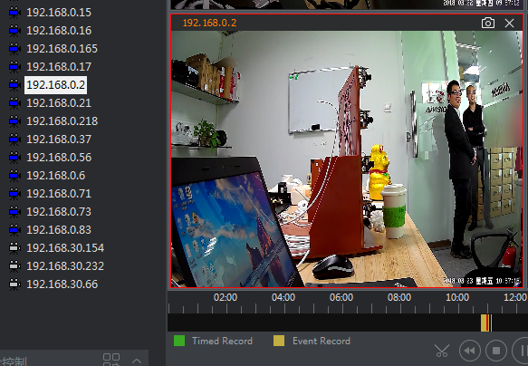
- Select the corresponding date and double-click on the IP to play the local recording of the playback device.
Note:
There is a shortcut to capture and turn off channel playback in the upper right corner of the video.

Remote playback
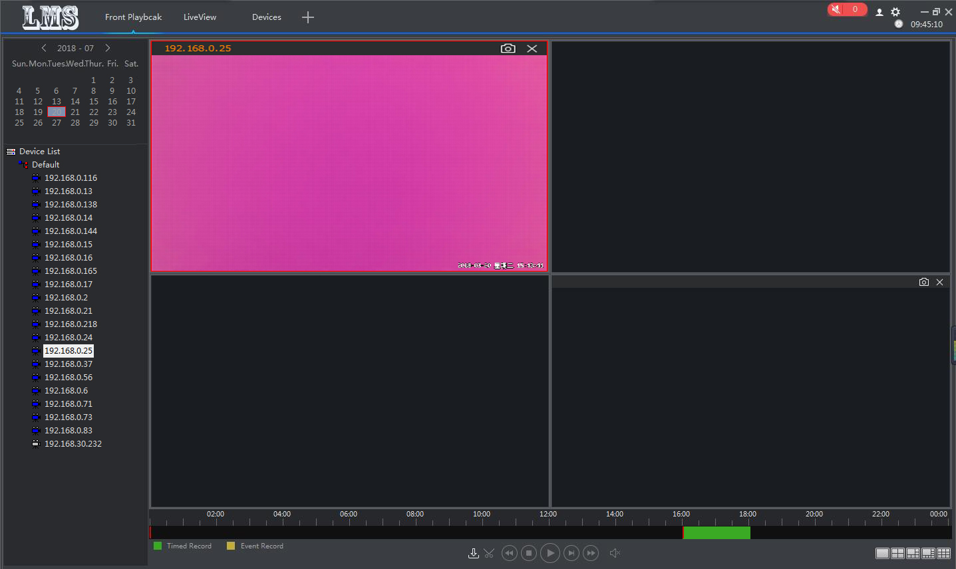
The remote playback device requires the device to have external storage. You can directly play back the front-end recording file by double-clicking the recorded video file. In the playback window, the user can operate the toolbar below the player to download video, time clip (reservation), rewind, stop, pause/play, frame advance, fast forward, sound and other functions. It can perform 1 picture, 4 picture, 6 picture, 8 picture, 9 picture simultaneous playback and different time period playback. Capture images are stored by default in the \LMS\SnapShot file, or you can view them in [System Settings] -> [Snapshot Directory].

System settings
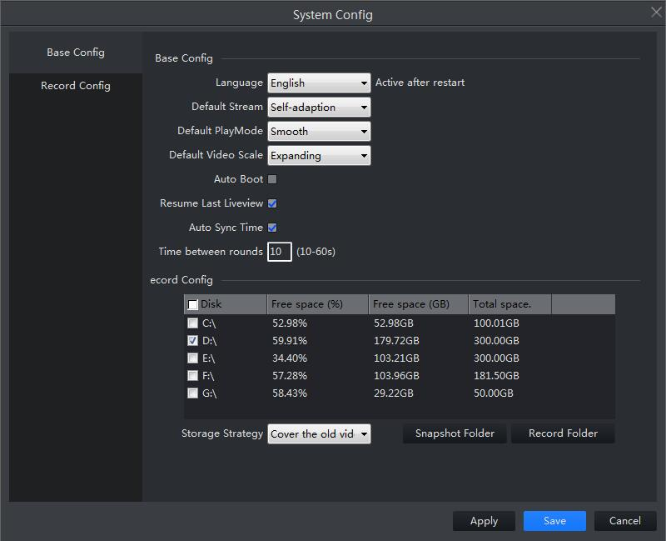12.1 Basic configuration
Configure system language, default stream, playback mode, video ratio, etc.
12.2 Video configuration
The storage status of the disk and the path to modify the video storage, the way to capture and record the directory quickly.

Other
Head Portraits
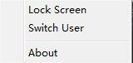 Lock screen, switch users, about version information
Current time
Minimize, maximize/restore, shut down the system

