Product Specifications

POE821Q
（48V Standard POE：IEEE802.3af/at）

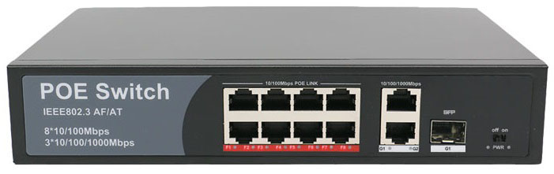
POE821Q supports data and power transmission through CAT.5 cables at the same time. And 8+2 port support fast connecting at 10/100/1000Mbps. It also supports vlan, fiber and coaxial cable etc. It reduces line losses effectively though 4-core cable supplying power same time.

Cost effective POE821Q provide a simple network for wireless AP, business and home that are based on the installation of IP Camera. These devices away from electrical outlets are very suitable for hanging on the wall or ceiling. PoE eliminates the hassle for these devices, specially the electrical outlets. Connect the AC power connection to make those difficult device more flexible, and the installation cost minimization.

Feature
◆Supply power to wireless AP and IP Camera through CAT 5 cable
◆8 Port: 10/100M auto sensing RJ45 port.
2 Port: 10/100/1000M auto sensing RJ45 port.
1 Port: 10/100/1000M auto sensing SFP port.
◆Support port auto-flip (Auto MDI/ MDIX)
◆Anti-thunder function for uplink port (Port 9-10 anti-thunder function reaches level 2)
◆Total PoE Power: 120W (Port 1 - 8 )
◆Max PoE power output is 30W.
◆Support Vlan
◆Switch Mode: Port 1-10: 10/100M auto-sensing. @100 meters; Port 9-10: 1000M @ 100 meters
◆Store and forward
◆Fanless design, natural cooling. Mini size.

Target Industries
◆HD monitor transmission and power supply
◆Wireless AP layout transmission and power supply
◆Network telephone transmission , intelligent house and home system
◆Intelligent transportation supervisory system(ITS)
◆ High-speed Way supervisory/Tele-Communication System
◆ Security protection system, TV medical treatment
◆ Long-distance Muti-media Schooling, Campus monitoring
◆ Long-distance broadcast television transmission system
◆ High-building Security Protection, Military Tele-Com projects
Ordering Information
Product Model: POE821Q
Product Description: 8x 10/100M copper RJ45 Ports+2x 10/100/1000M copper RJ45 Ports+1x1000M SFP Ports. standard PoE Switch. Port 1-8 support PoE function with port isolation function. IEEE802.3af/at, max PoE power output is 30W. Total power is 120W. supports Vlan. Built-in power supply.

Note: PoE Power Supply：1,2(+)/3,6(-) (Default) ; 45(+),78(-) (Option)

Product Name | 11-Port Standard PoE Switch
Model | POE821Q
Connector Type | 8x 10/100M copper RJ45 Ports+2x 10/100/1000M copper RJ45 Ports+1x1000M SFP Ports (All ports support MDI/MDIX auto sensing) Port 1-8: PoE port, max PoE output for each port is 30W.
Network Media | 100BASE-T: Cat5 UTP(≤100 meters); 1000BASE-TX: Cat5 or later UTP(≤100 meters);
Bandwidth | 10Gbps
Address Database Size | 2K
Network Latency | maximum delay less than 20 microseconds
Forwarding Mode | Store-And-Forward
Network Protocols | IEEE 802.3i 10BASET IEEE 802.3u 100BASETX IEEE 802.3x Flow Control IEEE 802.3af/at
Power Supply | Input: AC100-240V, 50-60Hz
PoE Ports | 8*PoE Ports
PoE Port Power | Max 30W
PoE Standard | IEEE802.3af/at
Working Environment | Operating Temperature: -20 ° ~ 55 ° C; Storage Temperature: -20 ° ~ 75 ° C; Humidity: 10% ~ 90%, non-condensing; Storage Humidity: 10% ~ 95%, non-condensing; Working Altitude: 3000 m (10,000 ft); Storage Altitude: 3,000 m (10,000 ft)
Certification | CE Mark ,commercial CE/LVD EN60950
Radiation | CE mark, commercial FCC Part 15 Class B VCCI Class B EN 55022 （CISPR 22）， Class B
Transmission Distance | Max 150 meters
Power Supply Type | 1,2(+)/3,6(-) (Default) ; 45(+),78(-) (Option)
Product Size | 200mm*120mm*44mm,1.2kg
Warranty | 3year

