Mobile Monitor
It introduces extra stream techniques when mobile monitoring, support channels switch(eg. Windows mobile)
Step1. DVR config, go to [Main Menu]->[System]->[Encode], enable Extra Stream.
Step2. install mobile monitor software to cellphone, get the software from CD enclosed, (the software for er successfully installing the software,finding and running "eg. vMEyev2" software through [start]->[procedure] in the mobile,see picture 13 android mobile is vmeyev2.apk )
Step3. Aft
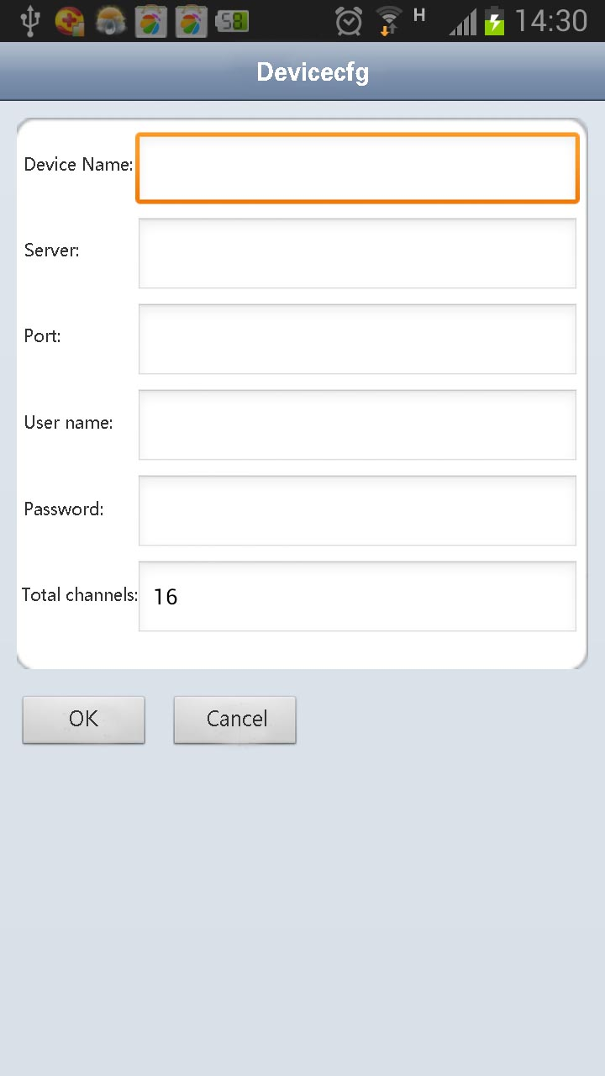
Pic 13 Mobile client side interface
Step4: click device list on above, input the IP address, user name, password, port
no. of the device that need to be monitored.
Device Name: user can set it as he like.
User name: login name of device
Password: password of device
Server: IP address of device
Port: 34567 (Remark: the port no. for vMEyev2 is default with 34567).
After added device, click yes, will see pic 14, choose the channel you want to monitor, the preview image will be displayed.
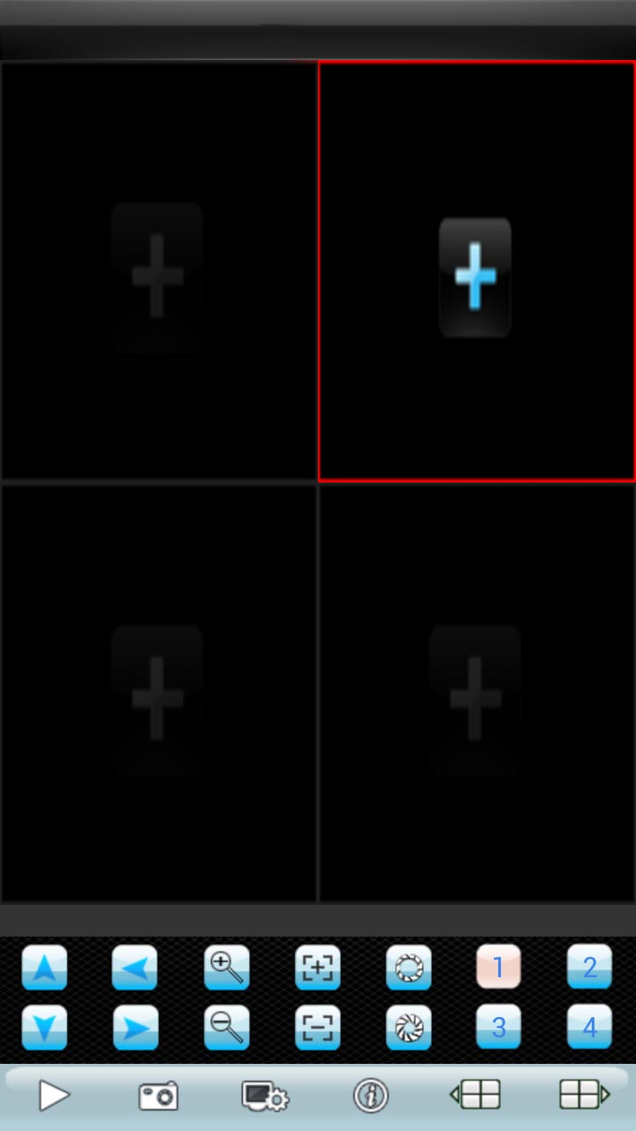
Pic:14 mobile monitor interface
Remark: when the DVR is in local area network, the mobile should connect to wireless router to access the device, each kind of mobile related to different client software ( due to different version, should be follow the version in the CD)

