

CSM monitoring software use manual
2013-9-24

声明
非常感谢您购买我公司的产品，如果您有什么疑问或需要请随时联系我们。

This manual maybe exist inexact in technology , product feature ,operation discrepancy or misprint. The content of the manual will renew according to the product function enhance, and regular change or renew either the product description or the process ,the renew content will add to the new version ,we will not make another notice.

Installation&working Environment

Summary
Suit to the small net monitoring file’s security monitoring equipment management software.base on windows platform ,can running on PC .
can browse the multi camera equipment realtime monitoring video.can browse the multi camera equipment playback video recorder.
can allocation multi timing broadcasting, realization all the computer on duty.
can allocation E-map, description the location of every equipment clearly.
can allocation setting item of the net video monitoring equipment alarm , realization linkage of the Management software&monitoring device alarm .
the function of the video automatic back ,main appliance to the without hard disk device background date backup.
For each device, each device window, each device channel can establish monitoring plan
For each user individually to create a profile, their habits and styles do not interfere with each other
operator management interface support both Chinese and English two language.
Attention： The software for the connection of multiple different types or types of equipment（NVR/HVR/DVR/DVS/IPC），This user manual describes only the operation of the software, related to the specific equipment settings please read the product description.
This manual is to provide responsible for planning, execution or review of network video monitoring software hardware installation personnel. You should have the related equipment (NVR/HVR/DVR/DVS/IPC) of the basic operation knowledge and experience.

Working Environment
O.S | Windows2000/XP/2003/Vista/Windows 7
CPU | above 2.4 GHZ
Graphics | Must support hardware graphic card (e.g. ATI、TNT2 PRO),suggest the use of dual channel graphics of ATI9800 or higher at 128M or above.
Memory | 1G or above
Screen | Recommend 1024*768 display resolution
NIC | 100/1000M
Prompt:If the management software to manage the channel decoded picture many suggestions, graphics card, CPU memory, choose the better configuration

Software Installation

Software Installation
Step 1: double click Cms2.0 installation package, installation interface appears as
below.
Step 2: Click "Next", select the software installation path, the default path
“C:\Program Files\CMS3.0”
Step 3: Click "Next" and wait for the completion of installation, click "Finish"
Prompt: If the computer has been installed on different versions of CMS, recommended to uninstall the original version of CMS, then according to the installation process of software installation

Software Uninstall
Method 1: click Start - program - Video Monitoring System - uninstall the video monitoring system, uninstall the software will delete all relevant documents, advice before uninstalling the video file and capture image file backup, so as not to be deleted
Mode 2: enter the system control panel, select CMS, as shown in the diagram below, select "delete", uninstall the software will delete all relevant documents, advice before uninstalling the video file and capture image file backup, so as not to be deleted.

Operation

Login Software
Step1: Double-click the Cms3.0 shortcuts generated on the screen, the login interface will appear, then enter the user name and password. The factory default user name is "admin" and the password is "123456" Tick the "Save password" at the bottom of the login screen to save user name and password so that you can login directly without having to enter the user name and password

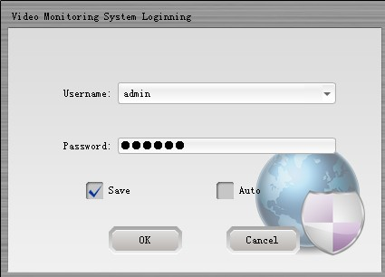

Step 2: click "login" user after authentication, enter the main program as shown below, click "cancel exit"!
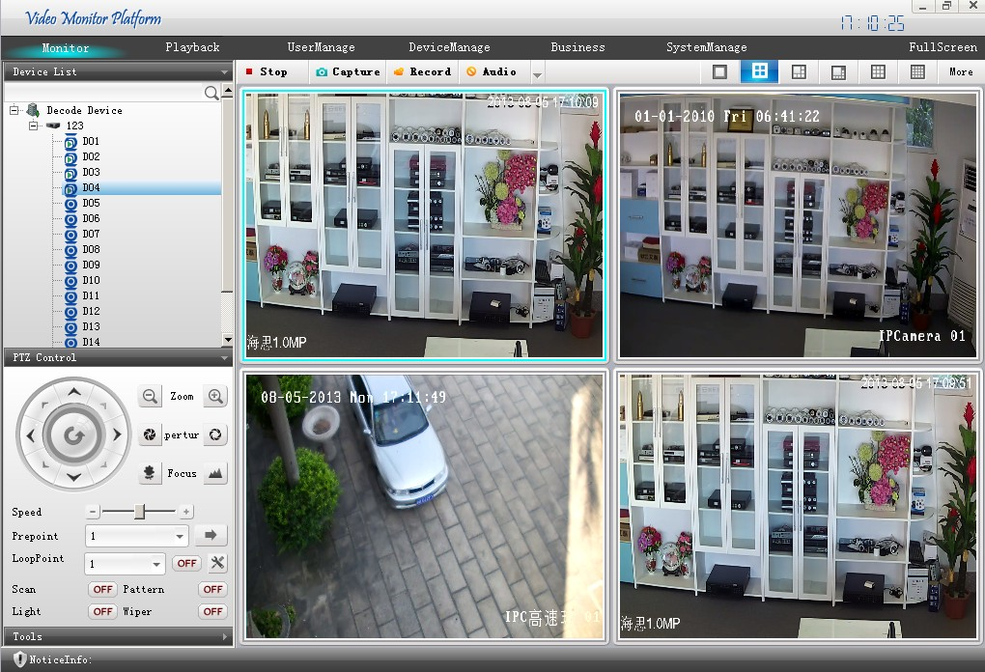

- 【The basic function of the software preview】
 | realtime monitoring | Multi windows realtime monitoring ,shortcuts,PTZAL control,etc.
 | retrieval playback | Query device video playback and download
 | User management | Add,alter,delete user.
 | Equipment management | Add&delete encode and decode, support automatic search function.
 | Business  management | To store and manage the equipment video, set the tour plan, TV wall is arranged, electronic map settings, set the alarm linkage.
 | system management | The language settings, power boot, auto start video program, restore the preview,The alarm configuration, time calibration, the store path video pictures, video space settings,Alarm log settings, user profile import and export etc.
② | interface split | click change video display windows(one/ four/ eight/ nine/ sixteen/ twenty-five/ thirty-six screens ).
③ | equipment list | Display has increased equipment to the "tree" form, equipment monitoring channel information
④ | monitoring windows | Multi interface realtime monitoring equipment video image ,click button carry out videotape,capture,talkback,monitoring
⑤ | PTZ control | click button to control the PTZ direction, camera chang times,focusing,diaphram  云台设置，设置预置点、线扫、巡迹、巡航等
⑥ | shortcut toolbar | quick positioning to shortcut function
⑦ | alarm message board | display device alarm log message ,etc.

Exit System

Click the “×”button which in the main interface top left corner, exit the software system.

Monitoring System Function

Realtime Monitoring
Real time monitoring mainly for monitoring equipment, can be directly browse the video surveillance equipment, also can open wheel patrol monitoring, control console monitor.

Video Interface Split
Click analog split Icon ,can split “main interface” video windows to one/ four/ eight/ nine/ sixteen/ twenty-five/ thirty-six screens

Equipment List
- Encode: Open the encode show device list, double click “device name” connect the device, The device name is channel display representation and connection; when the device is not online or add equipment parameters error is not connected with equipment. Double click the channel name can be viewed in real-time video monitoring window.
- Decode: Open the decode show device list, double click “device name” connect the device, The device name is channel display representation and connection; when the device is not online or add equipment parameters error is not connected with equipment. Double click the channel name can be viewed in real-time video monitoring window.
- Equipment name right key function:device is the DVR，NVR，HVR，encode In the connected device name. Click the right mouse button remote configuration, time synchronization, intercom, refresh "channel", open all the main stream, open all sub stream; equipment is IPC, not connected state can open the main stream and the open sub stream in the device name. Click the right mouse button, the connection state the device name. Click the right mouse button functions and other equipment right key function consistent.

Video Monitoring
Double click the channel number which in the device list can open the video ,click the right key will appear the operate menu, proper order is (close the window ,AUX, Local video, capture, interface quality)。

PTZ control

PTZ control interface as follows:
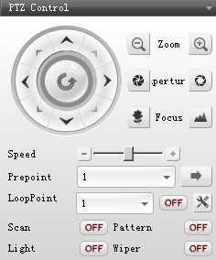

PTZ can be settled with 8 directions, Zoom, Focus, Lens, Distance, Preset Positions,
Tour , PTZ setting ( Preset positions, Tour)
click the opening video which you select（Windows have blue frame）,so that can control
PTZ( the channels’PTZ setting not give instruction)
1)【direction control】：To control PTZ up, down, left, right, pressure the mouse is controlling , loosen mouse is stop controlling
2)【change times】regulation control the PTZ camera’s lens to change times.
clickreduce the PTZ lens times,clickamplify the PTZ lens times:
3)【focusing】regulation control PTZ camera ‘s lens to change focusing distance.
click PTZ focusing will reduce，click PTZ focusing will expand；
4)【aperture】regulation control PTZ camera ‘s lens to change lens size.
click PTZ aperture lens reduce，clickPTZ lens ampliate.
5)【Length】：Control the direction Up,Down, Left, Right, Tour Speed by setting the Length.；
click - and + or moveto set the length；
6)【Preset Point】：Move the PTZ to the Preset Point after input the Preset point
Choose the preset point or input the number, click to move the PTZ to the Preset Point；
7)【Tour】： Set the Tour；
Choose the Tour, click and it would be The PTZ would move due to the tour，click to to stop the tour；
8) 【Auto Scan】: click to then the PTZ would start Auto Scan，clickto to stop Scan；
9）【Pattern Scan】: click to the PTZ would move due to the scan cruise，click to to stop cruise；

PTZ setting
click enter into the PTZ setting interface as below:
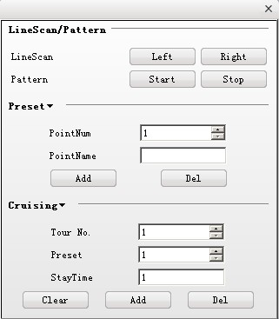

Auto scan setting
Operation：Choose the PTZ Auto scan left area by clicking the direction button ，Click left to do it, Same operation as the right area. Click right bottom to identify the right area. The Auto scan cruise is done。
Cruise Trace Setting
Operation: click on button to record the Cruise trace, Go to the Menu to set the Direction, Zoom, Focus, Lense. Go back to the Menu, Click OFF button. The Cruise Trace Setting is complete.
- advance point setting :
Operator: input the advance point NO., standing time ,PTZ rotational speed, click ADD ,addition the advance point: select the advance point NO. or input the advance point NO. by hand ,click DELETE to delete the advance point.

- Cruise Point Setting
Set the Cruise Number,add, delete or change the Cruise Point.

Shortcut Toolbar
- Color Settings
Color adjustment function is to adjust the color, hue, contrast, saturation to achieve the best visual effect
Operation: click and drag to regulating channels chroma, contrast, saturation, hue,etc.
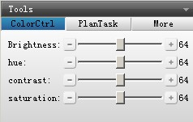
Auto Cruise and Alarm
In the Auto Cruise Plan function, Start the function by clicking the OFF at the right area, Stop the function by click ON button.
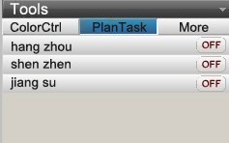
- Others Shortcut Function:
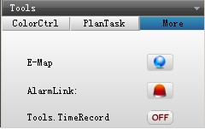

Electronic map shortcut function, click will popping electronic map preview interface as below :
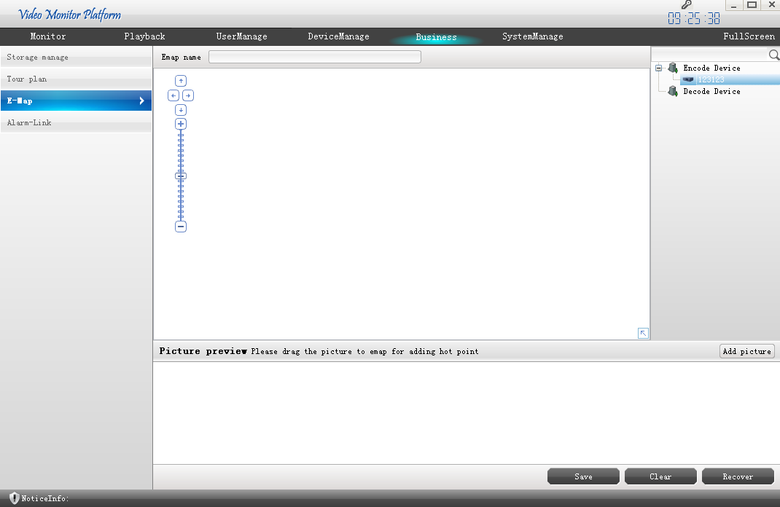

Alarm linkage shortcut function, click will popping video linkage’s video display interface, Shows the current alarm linkage video.

Video plan shortcut function,click OFF change to ON is starting the “video plan”, click ON change to OFF Is stop the “video plan”.

Alarm Prompt
Alarm real-time scrolling display alarm information, click the scroll area and view the detailed alarm information as below.
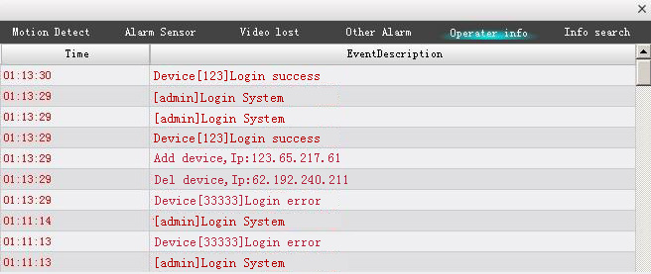

Equipment Management
Equipment management can add, modify and delete management of equipment operation, automatic search function of equipment support.

encoder interface management settings shown as below
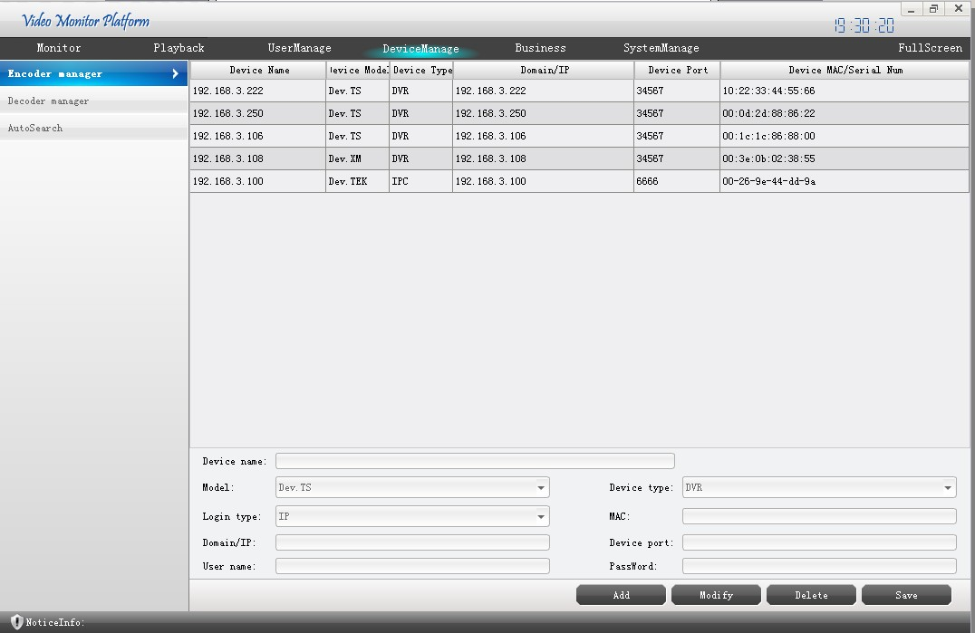

Preview: you can view the equipment information with information equipment IP, port, login etc. in the equipment list
Add equipment: in the edit box click the "add" button, the correct type parameters manually adding device, and then click "save" button to add to the list of equipment, equipment.
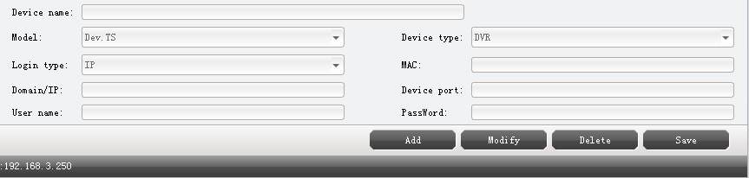
Editing equipment: selected equipment and then click the "Edit" button to change the relevant parameters, and then click the "save" button to save the new parameters.
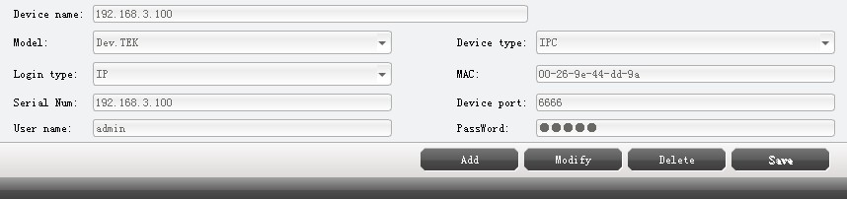
Delete equipment: selected equipment and then click the "delete" button to delete equipment.

decode management
Decode setting interface as below:
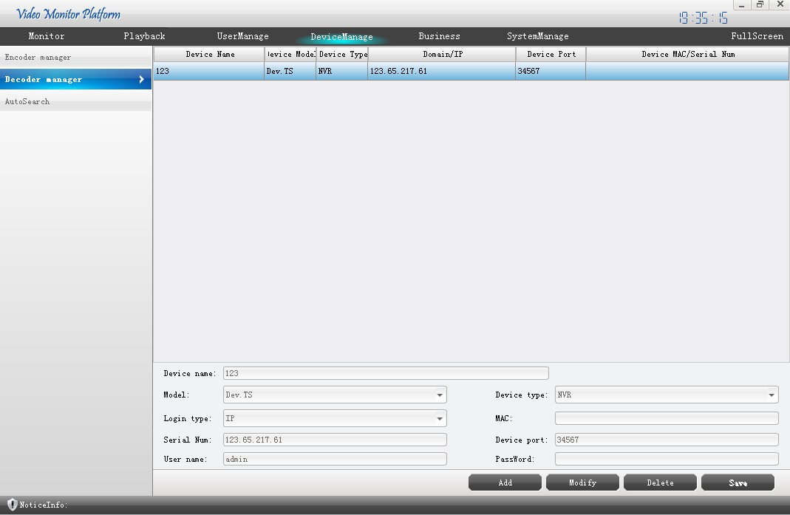
Preview equipment information: can check up the equipment detail information as device IP, port, log name etc. from the device list.
Add equipment: in the edit box click the "add" button, the correct type parameters manually adding device, and then click "save" button, the equipment is added to the list.
Apparatus for editing: selected equipment and click the "Edit" button to change the relevant parameters, and then click the "save" button to save the new parameters.
Delete the selected equipment: equipment and then click the "delete" button to delete equipment

Equipment automatic search
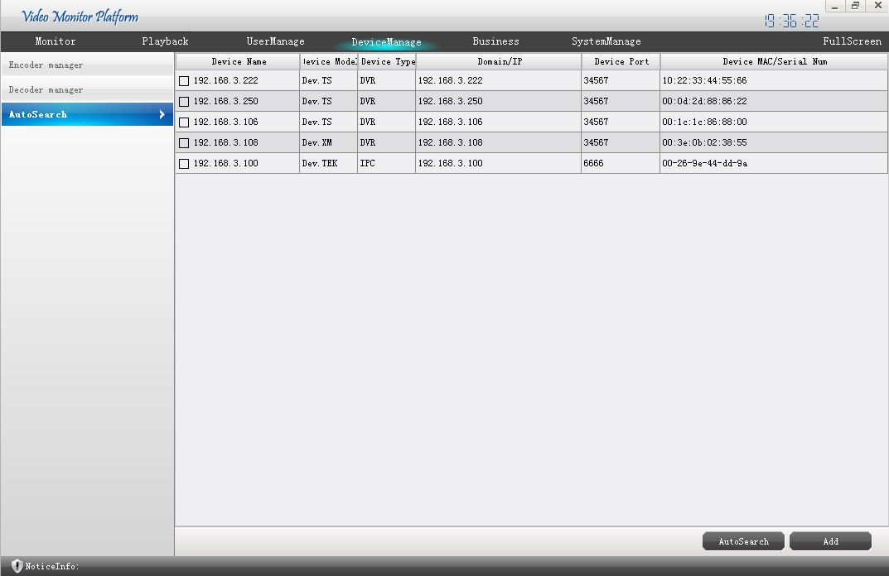

Click on "search" button, wait a little, to be the equipment appears, check the need to add the device and click "add" buttons equipment will be added to the corresponding encoding or decoding device list, add support equipment.
Note: 1, because the software by default after the addition of the user name admin password is empty port 34567, so in the equipment add equipment need username and password and port user manually change the parameters of the equipment can be normal use!
2, the equipment can not be repeated addition, device name and IP cannot add new and existing equipment repetition, repetition will prompt the user name or IP already exists!

Retrieval & Playback
The user can query the search playback of stored video equipment, and download the query to the video, but also query the local storage of video or a manual book like.

equipment video
Video recording equipment interface as shown below.
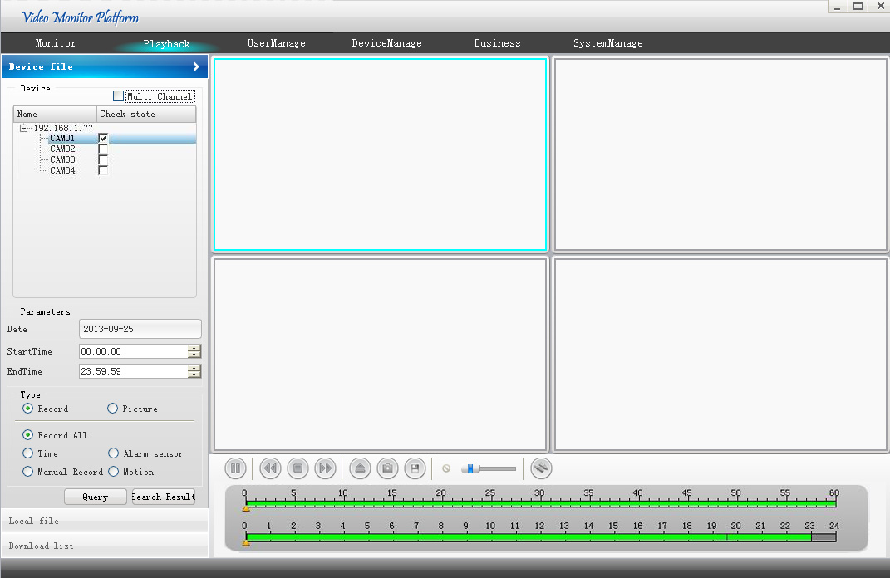

Equipment video query
Video queries have multiple retrieval conditions, equipment access retrieval, retrieval time, video or image retrieval, video retrieval type.
Video query operation steps:
The first step, select the device and channel number;
The second step, select a single channel or multiple channels, select the default is a single channel, in the playback only playback this channel; multi channel please add other channels (maximum support 4 channels), the playback synchronization playback after the addition of the channel;
The third step, select a date and time quantum;
The fourth step, select video types (video, alarm, manual, automatic detection of four kinds of video type);
The fifth step, CLICK QUERY view the file list in the "results".

Equipment video playback
In the query to the video file list and check the file to play, PLAY began recording playback, select the multi-channel playback is multi-channel video.
Replays play menu description
Channel playback interface as shown below.
open local video capture save
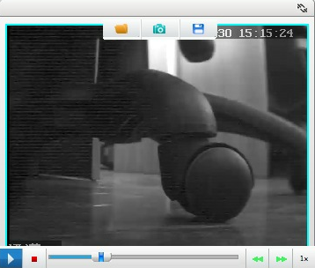
play/pause stop progress bar rolling ball slow play fast play play speed

3.3.1.3 Equipment video download
The download list shown as below
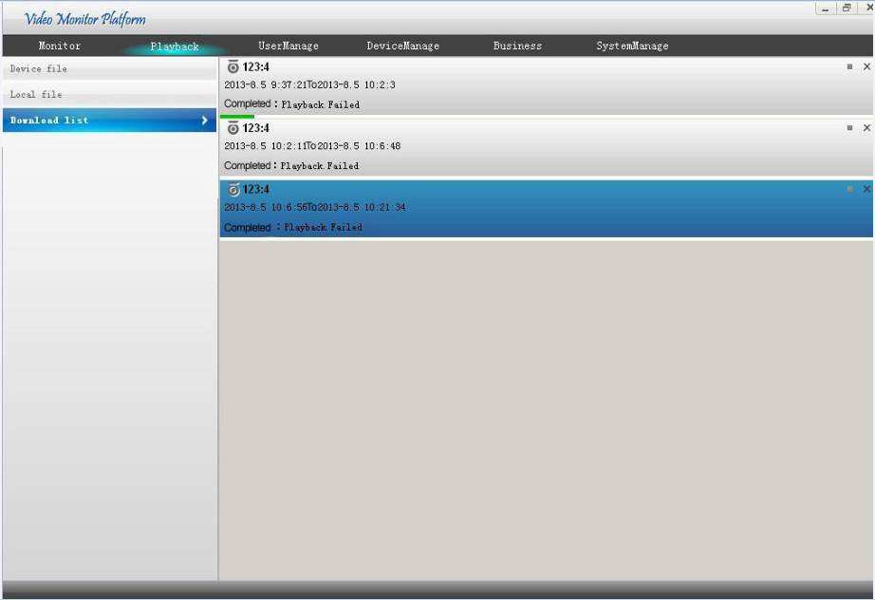

In the query to the video file list and check the file to download, click DOWNLOAD Start download, support multi task queue.
Download progress as below :
Video download pause: click pause download，click renew the download .
Delete download: click delete download task.
Channel name, Channel NO.
： Start and end time of video file
： Display video download progress

LOCAL VIDEO
Local video query and playback is stored video and manual recording the local computer hard disk video.
The local video query and play with the specific operation of video recording equipment operation.
Local video interface as shown below. ( query to video Click playback)
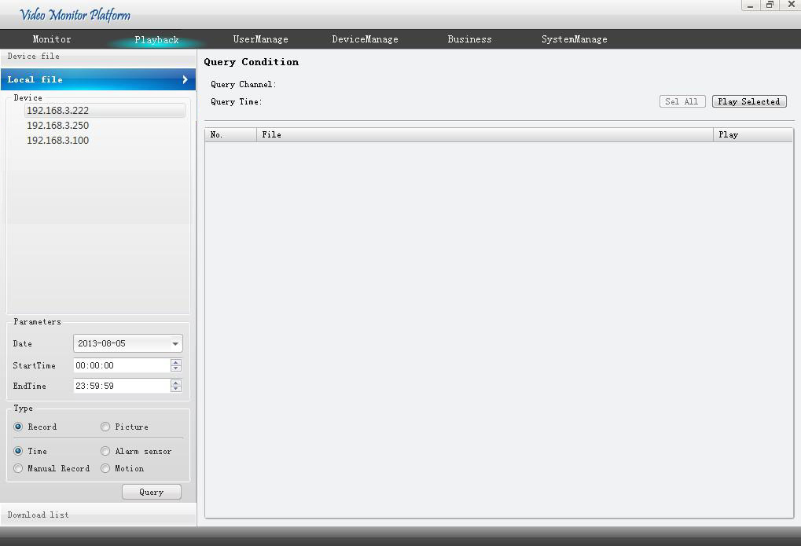

business management
Business management storage management, a round robin program, TV wall, electronic map, alarm linkage four big functions, can be better management of equipment, a more flexible view of monitoring equipment.

Memory management
Memory management interface as below:
Storage management can realize the client local real-time backup storage video, allowing multiple devices simultaneously in different time segment storage, storage, regular video and alarm video storage.
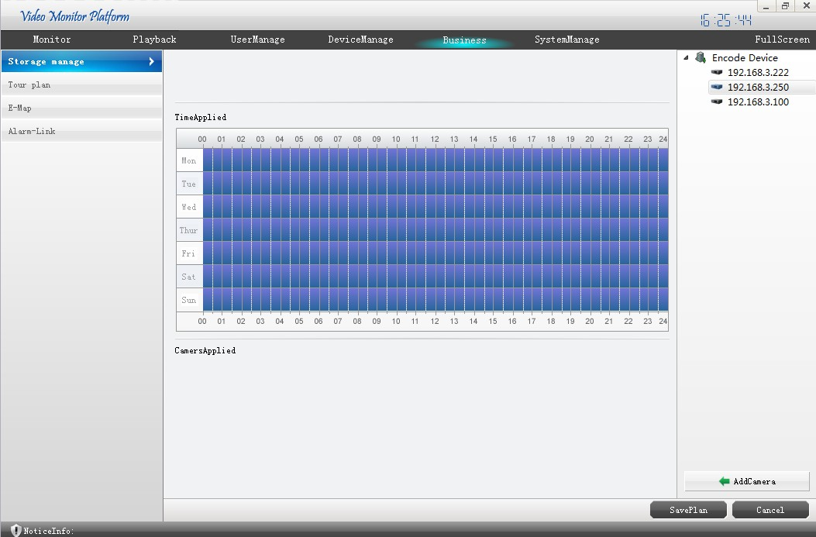

Operate Progress
The operation steps to add video storage plan is as follows
Step one, enter the storage plan name, select the appropriate video package time. step two, set up the video, can be set time.
Step three, adding to the backup camera, first select the device channel camera, then click the button to add a camera, camera to add after all are displayed in the "application list".
Step four, click the Save button, save all settings.
Step five, click the button to delete stored program, storage equipment selected button to delete.
Another note: alarm settings video time, is the alarm recording settings, alarm recording set alarm video instructions set linkage parts.：Check disk space: in full coverage of existing video, users have the important video data please backup.

轮巡计划
Auto Cruise can be settles as several ones for more convenient surveillance.

The Auto Cruise Setting Image as below ,
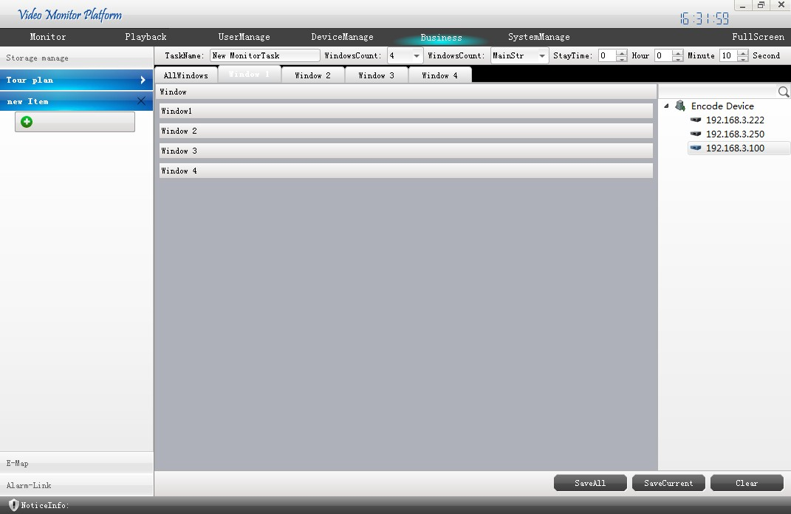

Operation
Start Auto Cruise function
Step one、Add new Cruise by clicking ADD。
Step Two、Add the Cruise Name, choose the windows number, and the Frame type (add the device channel’s frame type), Set the Cruise Time.
Step Three、Add the camera, Drag the Cameras at the right side to the window.
Step Four、Click the Button SAVE to finish the setting。
Step Five、On the Surveillance windows, click the OFF , and it turn to ON, on the Cruise Plan. Stop the Auton Cruise Scan by click ON.

Step Six、Delete the Cruise Setting by clicking .

Electronic Map
Display management of electronic map can allow users to clear the device location.
In the business management interface click map into the electronic map editor interface as shown below
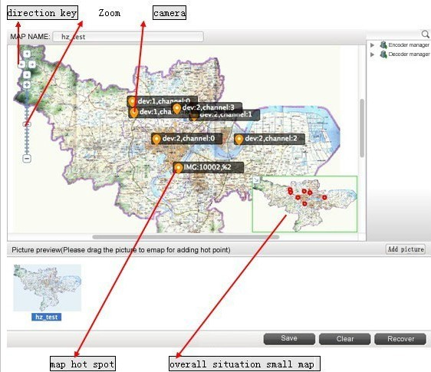

Electronic Map Addition

Add Picture
Click ADD PICTURE，pop-up pictures selection dialog box, browse pictures and fill in the name of the picture and picture description and then click OK add a picture.

Equipment layout on the map
Add a picture after good, double-click the pictures, upload pictures to the preview window, and then the right equipment list select the device channel the camera onto the preview picture, click the save, the map of the equipment added.

Electronic map cancel
Select the map you want to delete, and then right click REMOVE。Click EMPTY will clearing all map

Electronic Map Hot Spot Setting
Add multiple maps，e.g：could add BIN JIANG to HANGZHOU under the map as a hot.。
Operation: the left point of living BINJIANG drop to HANGZHOU of Binjiang is located in the position to set the focus.

Alarm linkage
Alarm linkage alarm camera video information feedback timely, to pop up video, localization plan, capture, record the alarm is triggered the alarm video camera.
Alarm linkage set interface as shown below
Add the alarm origin interface
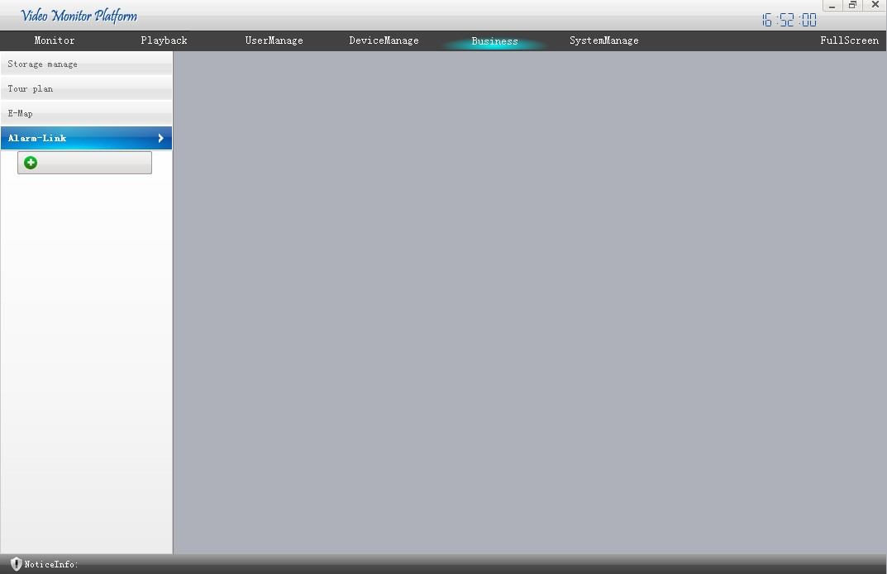
Built new alarm linkage operate progress as below:
Click the Add button in step one, the new alarm.
Step two, select the alarm type, select the camera under the right equipment list, select the display alarm window, residence time, the linkage of the preset point, then click on the Add button to add to the alarm list.
Step three, choose whether linkage storage (need to open storage plan), alarm before the video timing, alarm video time selection is triggered.
Step four, alarm configuration, optional location plan, alarm to capture, automatic voice playing (requiring the user to set alarm sound)
Step five, click the Save button to save the alarm configuration.
Step six, cancel the alarm task in the task list, the alarm task name right click the * delete selected alarm task.

User management
user management in the default admin is the highest authority of the user, the use of admin can log in to add, delete, edit the other user's operation.
The user management interface, can browse user, can view the user has permissions management equipment.
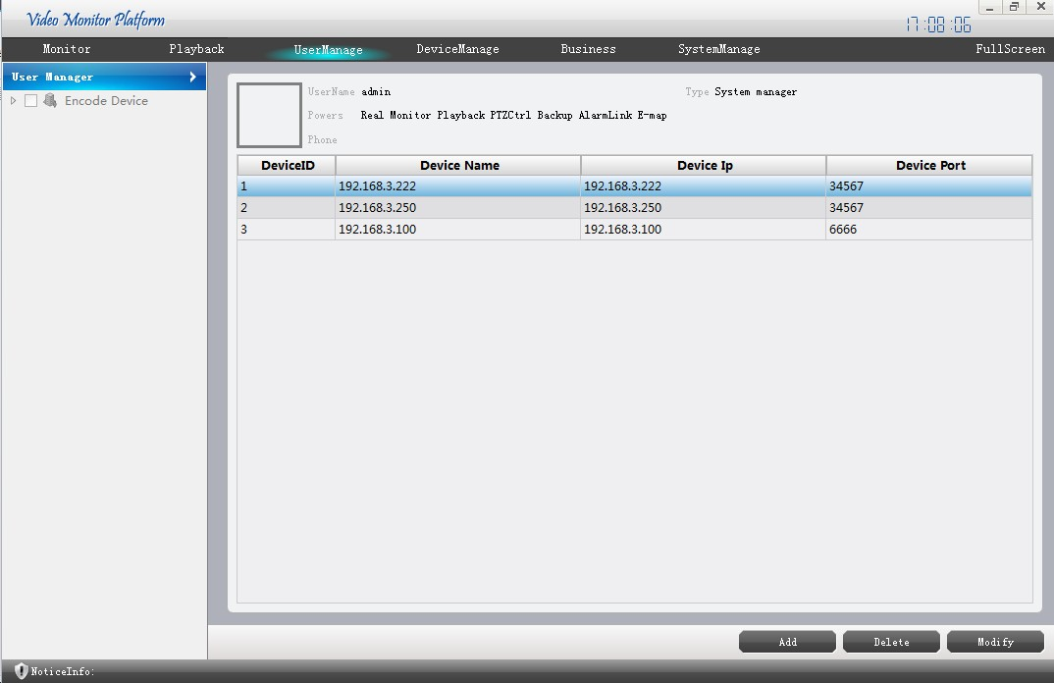

Add user

Change user

Delete user
Select the need delete user ,click DELETE popping confirm frame，and then click OK delete the user.

System Management
System management includes the client local setting, the store path pictures, video store path users can set up their own storage backup path, picture naming rules, video storage of hard disk capacity limit set, manual video automatic packing time, storage disk full overwrite; information preservation time settings, time settings, user profile import and export operating system log information stored alarm log configuration.
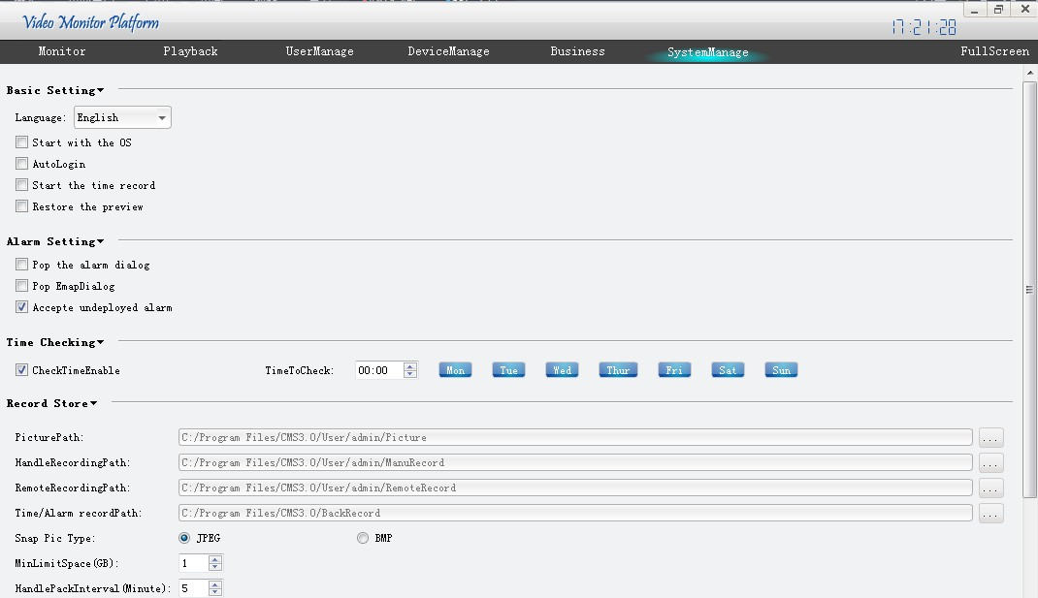

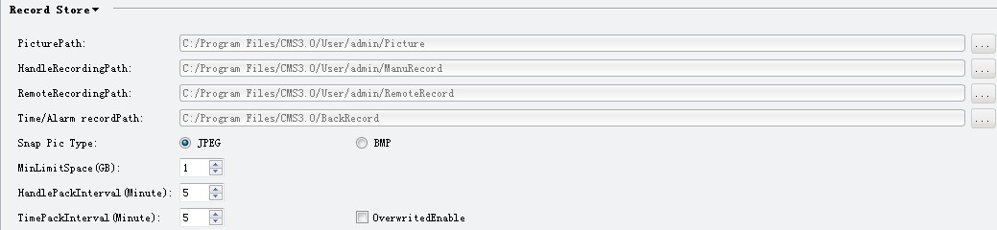

basic setting
The language settings: this software provides multi languages, Chinese and English optional.
Open the setup: check for the computer boot automatically start the software, not checked will boot the computer does not start automatically software.
Restore the Preview settings automatically: check the settings in the software after the restart keep running the last shutdown, such as monitoring, round robin task.

Alarm setting
Alarm sound settings: check the alarm sound, browse to the location of the sound file, click OK to save the setting.
Alarm: alarm pop up window settings pop-up linkage video in alarm trigger after the video window, select this option to select the pop-up window screen number, optional 1 or 4 window.
Did not accept the deployment information: select this option, the receiving system information.

Time Revision Setting
Automatic checkout time, check the calibration, and then set the check point in time selection cycle check time.

Video store local setting
Save path settings: user browse folder.
Picture naming rules:
Manual record keeping path settings: user browse folder.
Remote video keep path settings: user browse folder.
The backup process video keep path set: this path can be provided with a plurality of disk (set the interface as shown in the diagram below), click add new storage path, click delete the selected path, and then click OK to OK to save the settings, click Cancel QUITE setup.
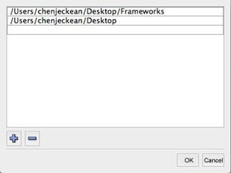

Others Setting
Log configuration: set the alarm and system logs record retention time, day as the unit.
。User configuration: export, user information, click EXPORT，then export settings location and file name, and then click OK export user information configuration file; the user information input, click IMPORT，and then browse the user information in configuration files, and then click OK import the configuration.
Attention: all the above settings after the operation must click OK to save the settings.

System Maintain
After the software working long time, if need to maintain, could click RESTART to confirm the software can regular work go on .

