GSM/GPRS/GPS
TK315 GPS Tracker User Manual
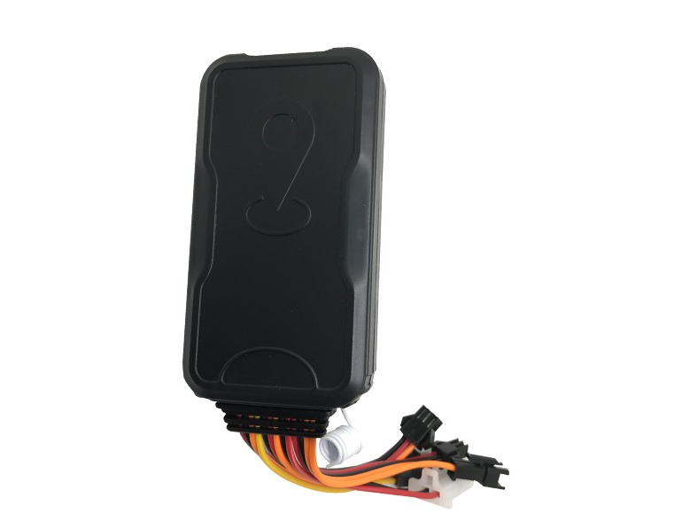

Preface

Thank you for purchasing the tracker. This manual shows how to operate the device smoothly and correctly. Make sure to read this manual carefully before using this product. Please note that specification and information are subject to changes without prior notice in this manual.
Any change will be integrated in the latest release. The manufacturer assumes no responsibility for any errors or omissions in this document.

◆Quick using

1）Open device silicone plug, proper insert GSM card, connect external power supply, Must turn on small switch near SIM card hole.
2） Put device outside, around 30s three lights will keep lighting on stands

for device can work normally.

3）Dialing device number, it will hang up and reply tracking message with valid Longitude and latitude.
4）If need track online system, send 2 SMS connects to platform as below:

SMS1:#ip#123456#a.gpstky.net#7700#

SMS2: #apn#123456#APN of operator#APN user name#APN password# 5）Login platform to track in real time(please contact supplier).

Specifications

Content | Specs.
Dim. | 98mm x 53mm x 15mm
Weight | 35g
Network | GSM/GPRS/GPS
Band | 850/900/1800/1900 Mhz
GPS chip | U-blox7
GSM module | MTK6261D
GPS sensitivity | -159dBm
GPS accuracy | 5m
Time To First Fix | Cold status 45s Warm status 35s Hot status 1s
Work voltage | 9V-36V
Storage Temp. | -40°C to +85°C
Operation Temp. | -20°C to +55°C
Humidity | 5%--95%

◆Installation attentions

NOTE: device front side towards the sky.

When install in car, if the windscreen glued by metal thermal insulation layer or heating layer, it will reduce the GPS receive signal and lead to GPS work disorder.
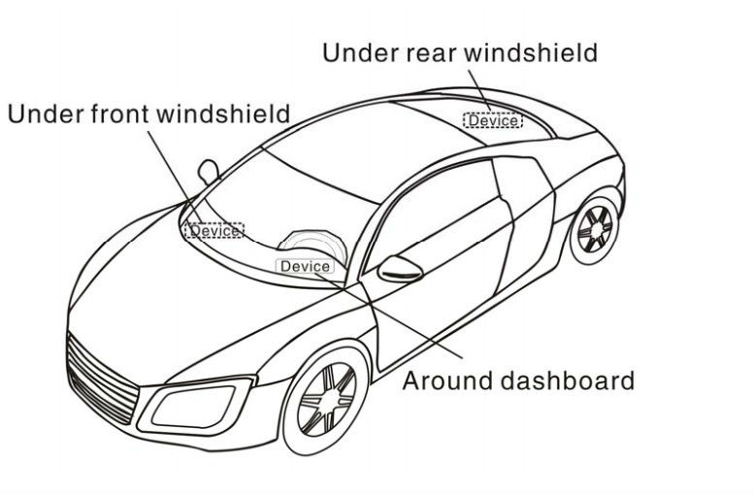

Device light description
Light | Represents
yellow | GSM signal normal
blue | GPS signal normal
Red | Power

1.Installation instructions

Preparation

      - Open the package to check the device model number is correct, be with full accessories, or else please contact your supplier;
Choose SIM card, need insert a GSM SIM card into the device, please refer to the suggestion of your supplier for SIM card choice.
Notice:

Please insert SIM card before turning the device power switch to on;
The SIM card need open the GPRS function;
Please make sure SIM card with full balance.

2.Device wiring requirements

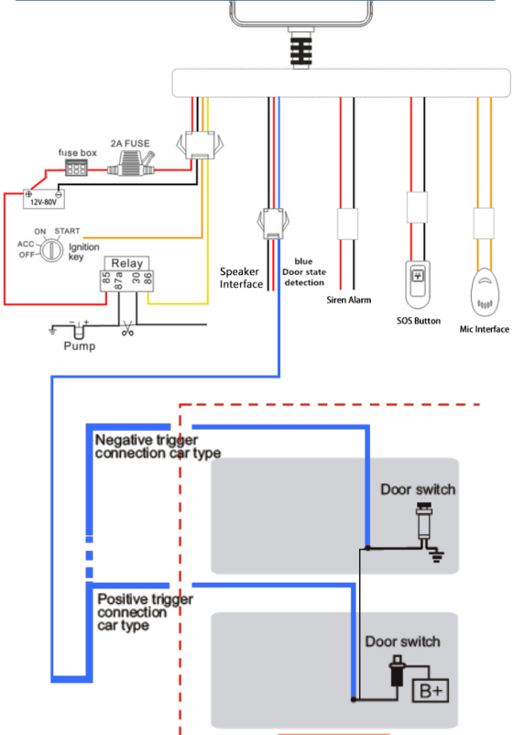

◆Attentions

◆Device light

1）No yellow light: failed to read SIM card, need reinstall SIM card. 2）Blue light flash: no GPS signal, make sure device started outside. 3）Three lights off: lights entered sleep mode, make a call or move device can wake up.
◆Device failed located

1）Failed located: message replied with all 0, make sure device started outside not in room.
2）Can’t reach the call: make sure SIM card has balance and installed

Properly and opened the switch.

◆Device can’t track on platform
1) Check three lights are stable on.

2) Make sure device can work and reply valid tracking long&Lat in SMS.
3) Send SMS #check#123456# , it will reply you device setting status to check IP,Port,APN etc.

- User Settings

1.Initialization (initialize the settings)
Text command | Parameter | Example
Command | #super# | #super#
Command Feedback | super ok

2.Single Locating : Two ways
1.Dialing tracking | make a call to device number, it will hang up and reply a real-time tracking message.
2.SMS tracking | Send SMS command,it will reply your location.
Text command | Parameter | Example
Command | #smslink#password# | #smslink#123456#
Command Feedback | Google link + Speed + Time + Date + IMEI

3.Authorized number (All alarm messages will be sent to authorized number only)
Text command | Parameter | Example
Add Authorized number | #admin#123456#phone number# | #admin#123456#18575518750#
Command Feedback | admin ok
Del Authorized number | #noadmin#123456#phone number# | #noadmin#123456#13409877890#
Command Feedback | noadmin ok（If notified not admin number,send #super# please）

4.Set password
Text command | Parameter | Example
Command | #password#old password#new password# | #password#123456#666888#
Command Feedback | Password ok

5.Set data to upload interval
Text command | Parameter | Example
Command | #at#123456#10~600# | #at#123456#10#
Command Feedback | at ok
Command description | The data upload interval can be set as you need, 10~600 represents seconds of data uploading interval, default as 30 seconds for real time tracking.

6.Device reboot
Text command | Parameter | Example
Command | #reboot#password# | #reboot#123456#
Command Feedback | reboot ok
Command description | The device will restart within 30 seconds

7.Set all alarm mode
Text command | Parameter | Description
Command | #KC#123456#0# | To close alarm function
Command | #KC#123456#1# | Alarm will reply only SMS
Command | #KC#123456#2# | Alarm will reply only call back
Command | #KC#123456#3# | Alarm will reply via SMS and call

8.Timezone Setting
Text command | Parameter | Example
Command | #timezone#password#direction#time zone value in hours#time zone in minutes# | In UTC-6 example:  #timezone#123456#W#6#00#  In UTC+5.30  #timezone#123456#E#5#30#
Command Feedback | timezone ok

9.Check vehicle state
Text command | Parameter | Example
Command | #check#password# | #check#123456#
Command Feedback | IMEI + Authorized number +Alarm mode + IP + GPS status + Data upload interval status + APN + Time zone + ACC status

10.Geo-fence
Text command | Parameter | Example
Command | #stockade#password#meter# | #stockade#123456#300#
Command Feedback | stockade ok
Command description | send SMS: “#stockade#123456#300#”, “300” represents 300 meters.In case of breach, it will send SMS “stockade alarm + IMEI + Coordinates” to the authorized number.

11.Overspeed alarm
Text command | Parameter | Example
Command | #speed#password#speed number in 3 digits# | #speed#123456#060#
Command Feedback | speed ok
Command description | Sample means When the car moves exceeding 60 km/h, the unit will send SMS alert “speed alarm +imei+ Coordinates ” to the authorized number.

12.Vibration alarm
Text command | Parameter | Description
Command | #vibrate#123456#1# | 1 means Slight vibration level
Command | #vibrate#123456#2# | 2 means medium vibration level
Command | #vibrate#123456#3# | 3 means high sensitive level
Command description | When the tracker detect the vibration,it will send “vibrate alarm + IMEI +Google map link” to authorized phone number.

13.Cut oil or electricity
Text command | Parameter |  | Example
Command | #stopoil#password# |  | #stopoil#123456#
Command Feedback | stop oil ok
Command | #supplyoil#123456# | #supplyoil#123456#
Command Feedback | supply oil ok

14.ACC alarm
Text command | Parameter |  | Sample
Command | #ACC#Password#1# |  | #ACC#123456#1#
Command Feedback | acc alarm on
Command | #ACC#Password#0# | #ACC#123456#0#
Command Feedback | acc alarm off
Command description | When the device detects the voltage input,it will reply “ACC Alarm+IEMI+Coordinates ” to authorized number

15.Switch between tracker mode, monitor mode,Two way communication mode
Text command | Parameter |  | Sample
Command | #tracker#password# |  | #tracker#123456#
Command Feedback | tracker ok
Command | #monitor#password# | #monitor#123456#
Command Feedback | monitor ok (Make a phone call,it will go through,then you can hear the voice around the tracker.)
Command | #call#password# | #call#123456#
Command Feedback | Call ok (The speaker will ring to notice you someone is calling you.Press the SOS button to answer the phone call ,and press again to hang up.When you want to call the admin number,press SOS button)
Command description | Device has 3 modes, the default mode is “tracker” mode.

16.SOS alarm
Description | When connect external SOS wire, if press the SOS button 3-4 seconds, device will reply "SOS alarm! +IMEI number+Long&Lat" to authorized number.

17.Power failure alarm
Description | If device was removed from car battery, device will end SMS “cut power alert! +IMEI number+Long&Lat” to the authorized number.

18. Door open detection alarm (Please check the wiring diagram for connecting)
Text command | Parameter | Sample
Command | #DA#password# | #DA#123456#
Command Feedback | set ok
Command description | #door#password#1#  #door#password#0# Negative triggering (Default for most vehicles,  when door is open, signal level of door  is 0V; when door is closed, signal level of door is power voltage.  Positive triggering: when door is open, signal level of door is power  voltage; when door is closed, signal level of door is 0V,once you set the door open alarm,it will send “door open alarm +imei+google map link” to authorized admin number.

19.Function of Remote Controller
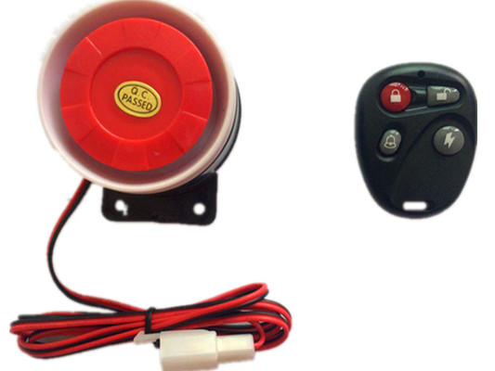
Button | Function | Description
Button “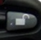”  Identical  #CF#123456# | DISARM | Press for 1 time, siren will beep 1 time.Then it will cancel “ARM” status and recover engine&Oil.
Button “”  Identical  #SF#123456# | ARM | Press for 1 time, siren will beep 2 time.(The Siren will ring when the door was opened illegally or detect the vibration.Siren alarm keep ringing until no vibration detected or disarm,also it will cut off oil&engine at the same time.If the tracker does not detect the vibration after 5 minutes,it will recover engine&oil,then it be back into “ARM” status again.
Button  “” | sos | Press for 1 time, device will send SOS alarm information to the authorization number.(The same function as SOS button)
Button “”  Identical  #FIND#123456# | Car search | Press for 1 time, siren will beep 4 time to help find the car.

Web based platform www.gpstky.net further details please contact manufacturer.
APP: Search: “Tracker King” in Google play store or Apple store.
1.Setting APN
1.1 APN standards for Access Point Name and differs from country to country. For more information about the local APN, inquiry from your local GPRS network operator.
1.2 Send SMS “#apn#password#APN content#APN user name#APN password#” via a cell phone and if succeeded, the tracker will return the message “set APN OK”.
E.g. send SMS command “#apn#123456#cmnet#”.
Notes: CMNET is the APN content of China Mobile (it has no APN user name and password).
2.IP and Port setting
Send SMS “#IP#password#ip address#port number#”. If succeeded,
“set ip address and port ok” will be returned by SMS.
E.g, Send SMS command “#IP# password #220.231.203.248#7700#” to the device (220.231.203.248 is IP,7700 is port, IP is in capital)

4.Cautions
Please comply with the instructions to extend the unit life:
1. Keep the unit dry. Any liquid, i.e. rain, moisture, may destroy or damage the inside circuitry.
2. Don’t use & store the unit in dusty places.
3. Don’t put the unit in overheated or overcooled places.
4. Handle carefully. Don’t vibrate or shake it violently.
5. Clear the unit with a piece of dry cloth. Don’t clean in chemicals, detergent.
6. Don’t paint the unit, this may cause some foreign materials left in between the parts.
7. Don’t disassemble or refit the unit.
8. Please read the user manual carefully before installation and operation, learn something more about the voltage range. Otherwise, it won’t work properly or destroy the product.

